House of Doolittle EXPRESS TRACK DESK PAD Calendar
17” x 22”

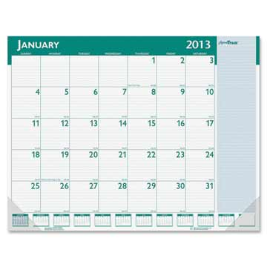
Item #: B1148
Desk pad offers planning pages that range 13 months from January to January. One-page-per-month format includes faintly ruled daily blocks (2-1/2" x 2-3/4"), Sunday through Saturday scheduling, ruled notes column and a full-year calendar reference along the bottom. Non-refillable desk pad is gummed at the head and has two clear corners to secure the calendar pages. Paper is made with a high percentage of recycled material.
- Media Size: 22" x 17"
- Color: Blue, Green
- Features: Non-refillable
- Placement: Desk Pad
- Block Size: 2.50" x 2.75"
- Layout: 1 Month per 1 Page
- Time Period: 1 Year - 1 Month
- Start Date: January
- End Date: January
- Date Format: Monthly

Blue Sky Designer MONTHLY DESK PAD Calendar

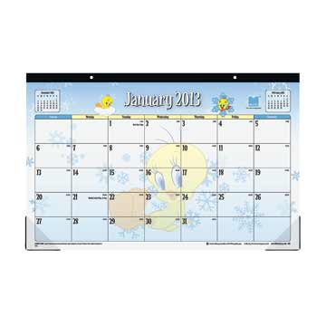

Item #: B112718-13
- Blue Sky - Designer Monthly Desk Pad Calendar - 11" x 17", Multicolor, 2013 Edition, Looney Tunes
2013 RY MO 17X11 LT DSKPAD
- 1 month per page (January-December)
- Include full-year overview reference calendar and ample writing space for appointments, notes and more
- Durable, heavy-stock paper offers a great writing surface
- Non-refillable

Blue Sky Designer MONTHLY DESK PAD Calendar
11” x 17”

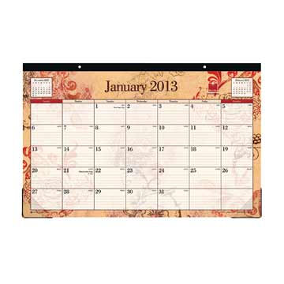

Item #: B112717-13

- 1 month per page (January-December)
- Include full-year overview reference calendar and ample writing space for appointments, notes and more
- Durable, heavy-stock paper offers a great writing surface
- Non-refillable

AT-A-GLANCE 2013 Daily Desk Calendar Refill

6" x 3-1/2"

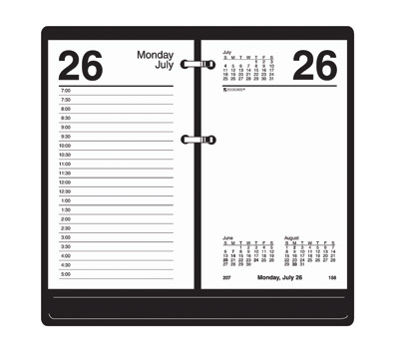
Item #: B1E71750-13
Features
- Ruled left-hand pages include scheduling times
- Unruled right-hand pages for notes
- 12 months (January 2013-December 2013)
- Half-hourly appointments, 7:00 a.m. to 5:00 p.m.
- 1 day per 2-page spread
- Past, current and future months reference
- Fits standard 17-style bases (sold separately)
- Page size: 6 x 3-1/2

AT-A-GLANCE 2013 Two-Color Daily Desk Calendar Refill White

3 1/2" X 6"

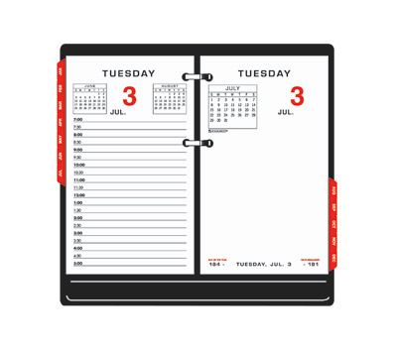

Item #: B1E01750-13
Features
- Page size: 3-1/2" x 6"
- 12 months (January - December)
- Half-hourly appointments, 7:00 a.m. - 5:00 p.m.; two pages per day with full weekends
- Past, current and future months reference
- One tab per month to allow for easy referencing of dates
- Fits standard 17-style bases
- Includes Monthly Tabs!

AT-A-GLANCE Recycled 2013 Weekly Designer Planner, Black

5-3/4" x 3-1/4"

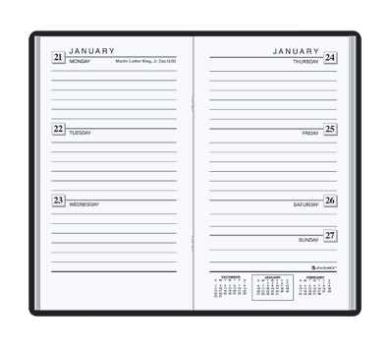
Item #: B17040205-13
Features
- Enhanced, simulated-crocodile cover material
- 12 months (January 2013-December 2013)
- 1 week per 2-page spread, ruled format
- Past, current and 1 future month reference
- Telephone/address section
- Advance planning section
- Page size: 5-3/4 x 3-1/4
- Black cover
- Non-refillable

Blue Sky 2013 Designer Weekly/Monthly Planner, Rue Du Flore,

11" x 8-1/2"

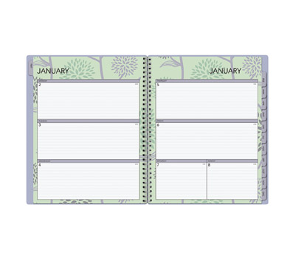

Item #: B113493-13
Features
- Pages are wirebound with heavy paper stock and durable covers
- Monthly 2-page spread features Mylar tabs for quick reference
- 1 week per spread format/1 month per spread format
- Page size: 11 x 8-1/2
- Non-refillable

DayMinder Premiere 2013 Recycled Monthly Planner Calendar

8-3/4" x 6-7/8"

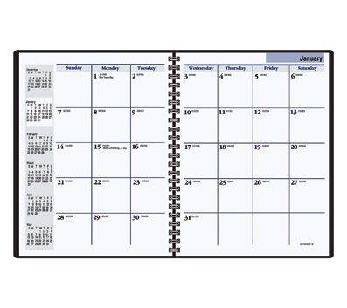
Item #: B140000-13
Features
- Includes memo section, space for notes and special information pages
- 12 months (January 2013 - December 2013)
- 1 month per 2-page spread
- Past, current and 4 future months reference
- Simulated-leather cover
- Page size: 8-3/4 x 6-7/8
- Softcover with tabbed monthly dividers, storage pocket and concealed wire binding
- Black
- Non-refillable

DayMinder 2013 Recycled Monthly Planner Calendar

11-7/8" x 7-7/8"

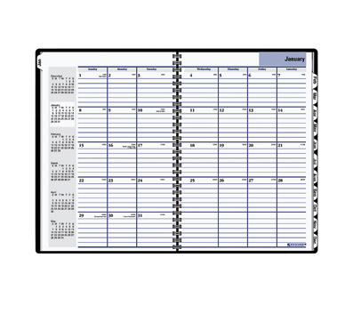
Item #: SK200-12
Features
- 14 months (December 2011 - January 2013)
- 1 month per 2-page spread
- Past, current and 4 future months reference
- Ruled daily squares
- 2-piece simulated-leather softcover
- Page size: 11-7/8 x 7-7/8
- Black
- Non-refillable

Blue Sky Designer 2013 SMALL Monthly Desk Pad Calendar

Barcelona, 11" x 8-3/4"

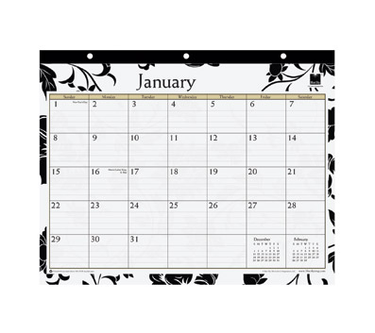
Item #: B112715-13
Features
- Black and white floral images on each month
- Heavy-stock paper provides a great writing surface
- Includes reference calendar and ample writing space for appointments, notes and more
- 12 months (January 2013-December 2013)
- 1 month per page
- Page size: 11 x 8-3/4

AT-A-GLANCE 2013 Recycled 2-Color Monthly Desk Pad Calendar

22" x 17"

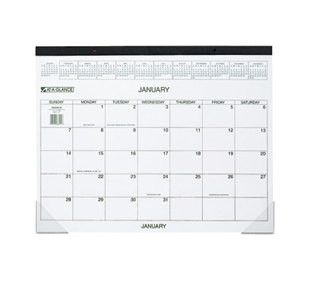
Item #: B1GG250000-13
Features
- 12 months (January 2013-December 2013)
- Full-year reference calendar strip at top
- Unruled daily writing blocks: 3 x 2-1/16
- Black headband with clear vinyl corners
- Page size: 22 x 17
- Printed in green and brown ink on quality paper containing 30% post-consumer content

AT-A-GLANCE Recycled 2-Color 2013 Desk Pad Calendar

22" x 17"

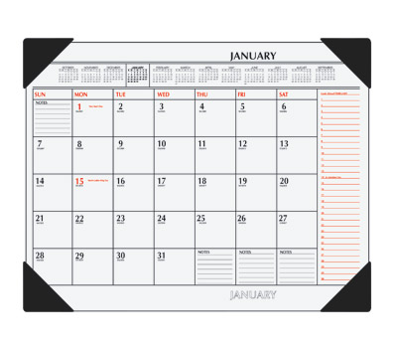

Item #: SK117000-13
Features
- 12 months (January 2013-December 2013)
- 1 month per page
- Full-year calendar reference with notes space
- Planning for next month
- Federal holidays noted in red
- 4 black vinyl corners
- Block size: 2-3/8 x 2-5/8
- Page size: 22 x 17
- Printed in black and red ink on quality heavyweight paper containing 30% post-consumer content

Top of Form

At-A-Glance Professional WEEKLY APPOINTMENT Calendar
8-1/4” x 10-7/8”
Bottom of Form
Top of Form

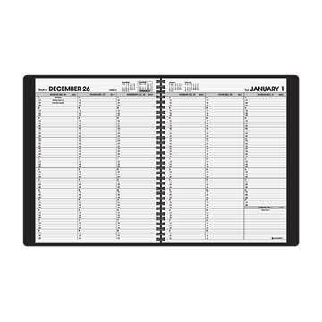

Item #: B17095005-13

- Annual or academic formats
- Perforated corners for easy reference
- Quarter-hourly appointments, 7:00 a.m. to 8:45 p.m. Monday-Friday; 7:00 a.m. to 5:30 p.m. Saturday
- 1 week per 2-page spread
- Past, current and 2 future months reference
- Telephone/address section
- Simulated-leather cover
- Non-refillable

AT-A-GLANCE 2013 Recycled MONTHLY WALL CALENDAR

15-1/2" x 22-3/4

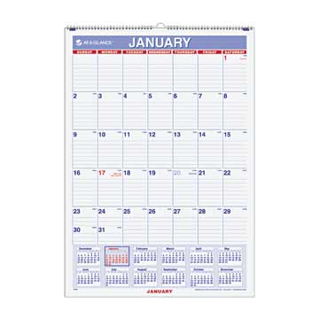

Item #: PM328-13
Features
- 12 months (January 2013-December 2013)
- 1 month per page with 12-month calendar reference
- Ruled daily blocks
- Full chipboard backing
- Federal holidays highlighted in red
- Printed in blue and red ink
- Wirebound with hanging loop
- Bonus page: 6 months of future planning
- Page size: 15-1/2 x 22-3/4
- Block size: 2-1/16 x 3-5/16

