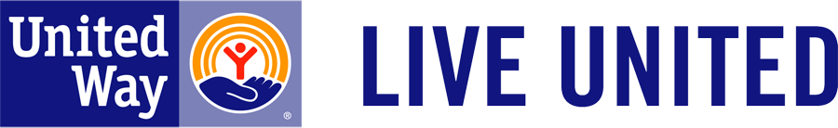
United Way Harvest Show
November 3rd, 2017
11:30a-1:00p

On Friday, November 3rd, the Purdue Research Foundation, in conjunction with the Purdue Railyard, will be hosting a lunchtime live music event benefitting our local United Way!

Local musician Eric Barr will be playing rock & roll and country music for your entertainment; all free-will donations will go to United Way.

Additionally, the Express Café, located in the Railyard, will be generously donating 10% of the day’s revenue to United Way.

So come out to the Railyard on November 3rd, enjoy some great food at Express Café with live music, and help support the Harvest Show for United Way!!

