
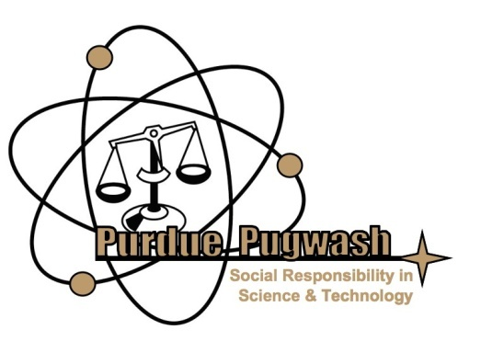

Access: Resources, Information, and Technology for the World

Today, more people have access to resources, information, and technology than at any point in history. Millions around the world can get clean water by simply turning on a faucet and can find almost any piece of information they could need through the Internet. Many can illuminate their homes with the flick of a switch and rest assured that their families will not starve due to famine. And yet as an image of the Earth at night reveals, despite the glowing lights of cities and highways that crisscross our continents, much of humanity is left in the dark.
The work of building access for the entire world is not finished, but is moving fast and is leaving a vastly improved standard of living in its wake. At this conference, you will learn how people at the front lines are pushing the boundaries of global access to resources, information, and technology, whether through building sustainable wells and water treatment in rural Nicaragua, to fighting censorship in repressed states, to creating new breeds of staple crops that can resist droughts and prevent famine. Our keynote speaker is Mr. Douglas Gardner, Deputy Director of the United Nations Bureau of Development. He will speak on the state of access in today’s world, and about progress in attaining the Millennium Development Goals, the ambitious goals set forth by the 192 member states of the UN in 2000 to greatly improve the lives of Earth’s six billion plus inhabitants. Our final speaker will be Mr. Zach Exley, Chief Community Officer of the Wikimedia Foundation, who will give an address on Wikipedia and the future of access to knowledge. The world is changing in exciting ways; come listen to the experts, discuss the issues, and learn about the state of access in today’s world.

~

Pugwash strives to provide a forum for discussion of the social and ethical impacts of science and technology. True to our origins as a response to the threat of global nuclear war, in the past we have often focused on the dangers of, or caution needed with, new technologies. We have examined critical issues facing the world ranging from integrity in science to the healthcare system to the relationship between energy and the environment, always looking for the pros and cons of all options. Keeping this critical spirit in mind, with this year’s conference we hope to emphasize the enormous potential for human betterment offered by science and technology rather than the potential for danger or disaster. Universal access to resources, information, and technology is a grand challenge, but it is one that is filled with enormous promise.

Access: Resources, Information, and Technology for the World
2011 Pugwash Conference Agenda

FRIDAY, APRIL 1, 2011

6:00 p.m. – 7:30 p.m.: Preconference Event: Designing for Access

7:30 p.m. - Conference Social

SATURDAY, APRIL 2, 2011

9:00 a.m. – 9:30 a.m.: Breakfast & Check in

9:30 a.m. – 10:30 a.m.: Foundations of Access: US Agency for International Development
Long term, sustainable access to resources and information requires a stable society and government, and certain infrastructures and institutions. Rule of law, low corruption, and access to markets are all issues that must be addressed in order to maximize development and to best improve citizen’s quality of life.

10:45 a.m. – 11:45 p.m.: Breakout Session # 1
Topics: Access to Electricity: Blue Energy
Access to Clean Water: Mr. Mike Paddock, Board of Directors for Engineers without
Borders
Access to a Secure Food Supply: Dr. Gebisa Ejeta, winner of the 2009 World Food Prize,
Purdue University

11:45 p.m. – 12:45 p.m.: Lunch

12:45 p.m. – 2:00 p.m.: Keynote: The State of Access and the Millennium Development Goals: Mr. Douglas Gardner, Deputy Director of the United Nations Development Program Bureau of Development
The world is changing. Great strides are being made to reduce poverty, and to provide access to resources, information, and technology throughout the world. At the dawn of the 21st century, the United Nations established a series of development goals (the Millennium Development Goals) for the world to reach by 2015, and foremost among them were issues of access. Learn about the progress of these global goals, and how they will develop in the future.

2:15 p.m. – 3:15 p.m.: Breakout Session #2
Topics: The Barrier of Censorship: Reporters without Borders
Access to Media and the Internet: Dr. Patience Akpan-Obong, Arizona State University
Access to Education: Dr. Mohammad Najeeb Shafiq, University of Pittsburg

3:20 p.m. – 4:00 p.m.: Discussion Workshop

4:10 p.m. – 5:30 p.m.: Wikipedia and the Future of Access to Knowledge: Zach Exley, Chief Community Officer for the Wikimedia Foundation
If you use the Internet often, it is almost certain that you have used Wikipedia at some point. This free online encyclopedia contains information and links about almost any subject imaginable, and is continuously updated by volunteers. The availability of this knowledge has had a tremendous impact on the developed world, and its model of decentralized compilation, validation, and organization of knowledge is a fairly recent phenomena. Learn about how access to information has changed in the Wikipedia age, and what this means for the future.

