Annual Safety Training

Annual Safety Training is required by all students who plan on working on the lab floor.

At the beginning of the fall semester, you will be notified in the Friday Safety Meeting to register through the Bowen Lab Intranet and complete the Annual Safety Training. Failure to complete Safety training will result in having your lab privileges denied and key fob deactivated.

How to Register
Start here:
https://engineering.purdue.edu/Bowen
The Page will look like this:
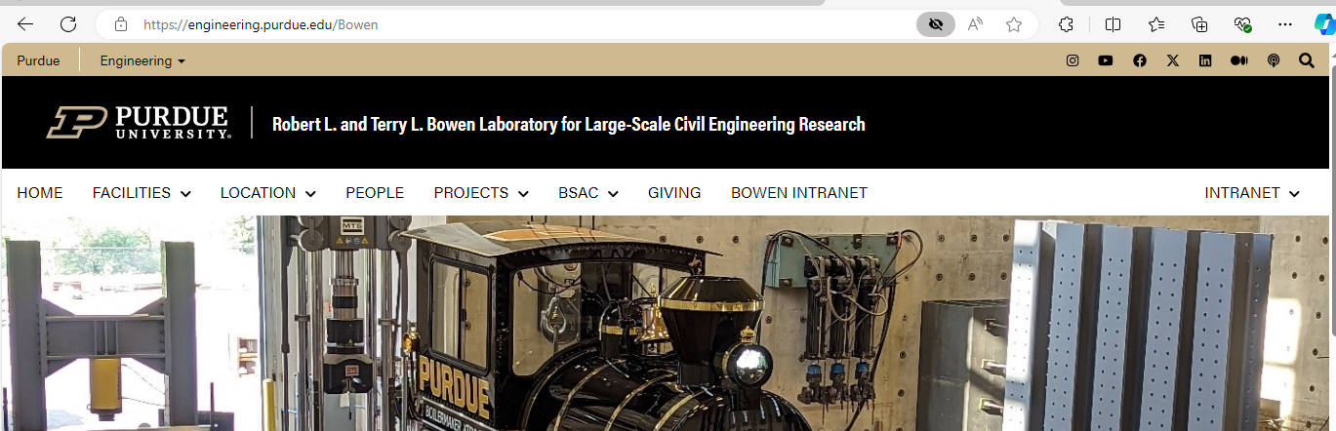

Click on:
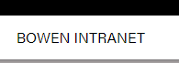

Click on:
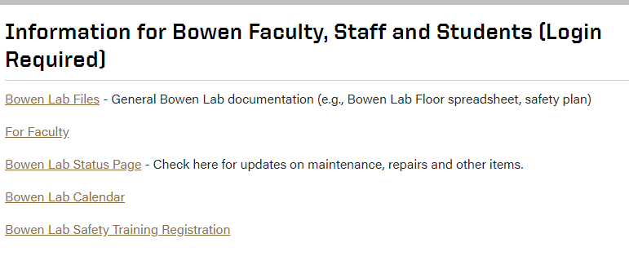

Click HERE:
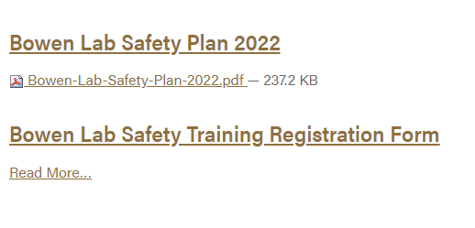

Fill out the form that pops up.
This will generate an email for your training.

Once the email is received, you will then receive an email that looks like this:
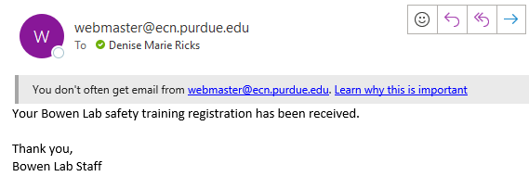
Next you will receive the email with the link and temporary password from HSI Platform that should look like the below snip-it, but with your personal information.
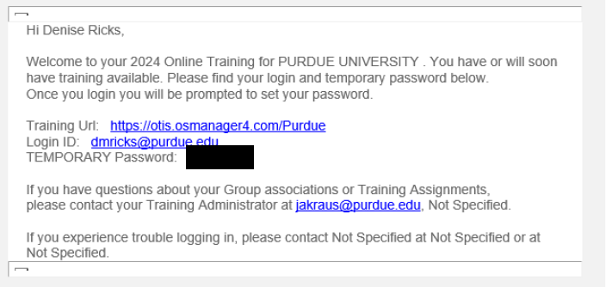
Once you go to the training URL, you can log in and complete the assigned training.

Just because you have items to complete in your HSI portal does not mean you have completed Safety Training. YOU MUST REGISTER!

