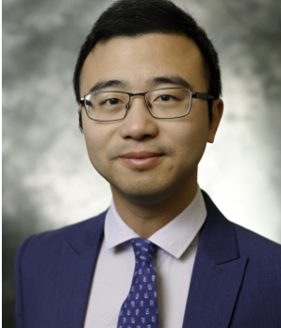
Seminar Title: Bridging Robotics and Artificial Intelligence (BRAIN) for Industrialized Construction

Speaker: Shuai Li, Ph.D.
Associate Professor of Civil and Coastal Engineering
Engineering School of Sustainable Infrastructure & Environments
Purdue University

Meeting time: Friday, 11/7/2025, 11:30am-12:20pm
Meeting location:
https://zoom.us/j/4938986199?pwd=R2lKMkxSNXVYT0R0VU9zZ0RkbmZ5dz09

Abstract
Advancements in robotics and artificial intelligence (AI) present both challenges and opportunities for future construction and built environments. In this seminar, I will present our efforts to bridge robotics and artificial intelligence for future construction and building systems, propelled by technological innovations in digitalization and robotization. For construction digitalization, I will present an industry-inspired interdisciplinary engineering project that developed an embodied AI co-pilot to digitalize the construction process and streamline communication, addressing the longstanding issues of low productivity and high rework rates in the industry. A laser ink display-based spatial augmented reality technology is developed to convey construction information on job sites and a large vision-language model is adapted to provide in-situ and real-time guidance for construction workers. For construction robotization, I will introduce our generalizable robot learning approach to transition from robot teleoperation to human-robot collaboration and ultimately toward full construction automation. A keyframe-guided and goal-conditional learning framework is developed to enable robots to learn from teleoperation data for complex construction operations. To ensure seamless human-robot collaboration in dynamic construction sequences, a federated learning approach is developed to predict multi-level and implicit human intentions for robots to plan their actions. In addition, large language models are exploited with learned robot intelligence to convert explicit human intentions into robotic actions to achieve higher autonomy in complex construction tasks and new environments.

Bio
Dr. Shuai Li is an Associate Professor in the Department of Civil and Coastal Engineering at the University of Florida. Previously, he held the David Goodpasture Endowed Associate Professorship at the University of Tennessee, Knoxville. He earned his Ph.D. in Civil Engineering from Purdue University, where he also completed three Master’s degrees in Construction Engineering and Management, Industrial Engineering, and Economics. Dr. Li's research focuses on bridging robotics and artificial intelligence with the data revolution to advance technological innovations for advanced construction and manufacturing. His work contributes to the nexus of civil and environmental engineering, robotics, and artificial intelligence. He has secured more than $10 million in competitive funding as PI or Co-PI from NSF, ARPA-E, DOT, and technology companies. His work has resulted in over 100 publications in leading journals and conference proceedings. Furthermore, Dr. Li's exceptional contributions have been recognized with several awards, including the Chancellor's Award for Professional Promise in Research and Creative Achievement, the David Goodpasture Faculty Endowment, the Tickle College of Engineering Professional Promise in Research Award, and the Success in Multidisciplinary Research Award, from the University of Tennessee Knoxville. He is also a recipient of the Collingwood Prize from the American Society of Civil Engineers and the Best Paper Award from the Journal of Building and Environment.

