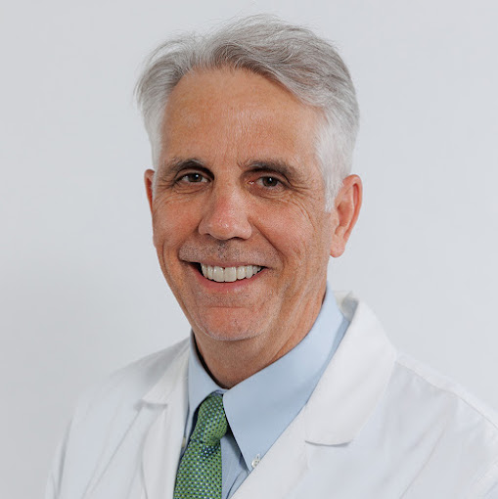

Dr. Mark S. Slaughter, Purdue BSCE 1982
Cardiovascular and Thoracic Surgery at U of L Health – Heart Hospital. Dr. Slaughter is professor of Surgery and chair of the Department of Cardiovascular and Thoracic Surgery at the University of Louisville and has an adjunct appointment in the Department of Bioengineering. In addition, he serves as the director of the Heart Transplant and Mechanical Assist Device Program at the University of Louisville and U of L Health – Jewish Hospital. Dr. Slaughter currently serves as a consultant to the FDA Medical Device Review Panel, National Science Foundation SBIR/STTR grant reviewer and previously served two terms for the Health and Human Services Medicare Coverage Advisory Committee. Dr. Slaughter has served as the president of the American Society Artificial Internal Organs and president of the International Society of Rotary Blood Pumps. Dr. Slaughter is the editor-in-chief of the American Society of Artificial Internal Organs Journal and also serves as Chairman, Department of Cardiovascular and Thoracic Surgery, University of Louisville School of Medicine (U of L). Dr. Slaughter was also the Gordon Research Conference Co-Chair for Mechanical Circulatory Support sponsored by the National Institutes of Health, 2017. Named Physician of the Year by Medical News, 2010.
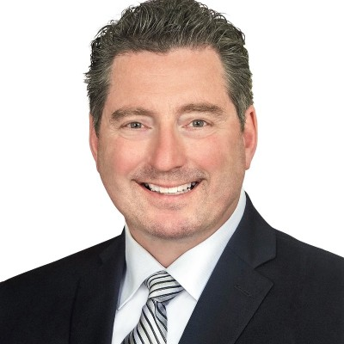

Lance D. Hansen, BS 1988 West Point, MSE Purdue 1995, PhD 2002
Manager (R&D) Design, Build, Test, Deploy, Exploratory Systems Technology, Sandia National Laboratories Sandia National Laboratories Livermore, California, United States
Senior Leader (Retired)
U.S. Army Engineer Research and Development Center (ERDC) · Champaign, Illinois, United States
Director, Construction Engineering Research laboratory (CERL), US Army Engineer Research and Development Center (ERDC). Executive oversight of an internationally known Army Laboratory with unique technical and operational capacity of approximately 300 staff supporting Army and National S & T requirements.
Deputy Director, Cold Regions Research and Engineering Laboratory (CRREL). When at CRREL, revolutionized Improvised Explosive Device (IED) detection for CENTCOM. This gave US forces the capability to destroy in excess of 100,000 lbs. IED raw materials, interdict in excess hundreds of IED emplacements and in doing so, saved lives otherwise lost to those embedded IEDs had they been allowed.

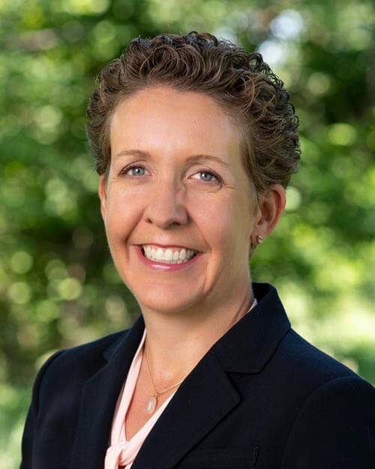
Nicole Speece Laiho, P.E., BSCE 1997, MSCE 1999,
Managing Partner & Chief Operating Officer, Peak Engineering, Lakewood, Colorado
Responsible for business relationships with developers, contractors and architects throughout Colorado and across the U.S.; growing client base and increasing annual revenue by more than 50% in 2021; managing multiple projects and personnel; planning team building activities. Ms. Laiho designed millions of square feet of commercial real estate in multiple states including: Colorado, Florida, Idaho, Maryland, Massachusetts, New Jersey, New York, Ohio, and Pennsylvania. Elected to the Board of Directors in 2020 and became a 50% owner in January 2023 and now Peak Engineering is 100% woman owned. Spearheaded the effort to achieve Federal Status as a Woman Owned Small Business (WOSB) and Peak was awarded this honor in September , 2024.
Design Engineer at S.A. Miro, Inc. where Ms. Laiho was responsible for all phases of building design from Schematic Design to Construction Administration and became a member of the Miro’s MASTER COMMITTEE directing the creation, verification, and adaptation of office standardized spreadsheets used for design calculation.
Licensed Engineer in 26 States in the U.S.

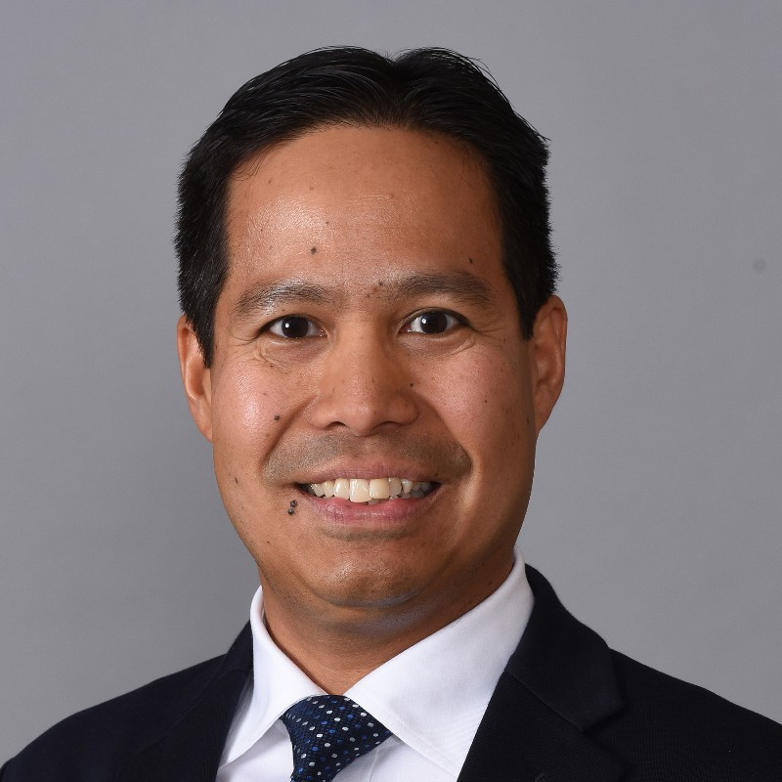
Mike Wongkaew, P.E., S.E., PMP, BSCE 1996, MSCE 1997, Ph.D. 2000, Senior Vice President, AECOM, Seattle, Washington. “Americas Tunnel Practice Leader”
Engineering practice leader with strong technical and practical background. Demonstrated ability to engage team members across organizations, offices, and disciplines to collaborate and deliver award-winning projects. Diverse transit and transportation infrastructure delivery experience across the western US from conceptual engineering and alternative analysis, to the preparation of final design and design-build contract technical requirements, to field and office engineering during construction, and inspection and retrofit of assets in service. Proven records of delivering innovative and practical solutions that address challenging stakeholder requirements while managing risks and costs.
Past accomplishments included designing the first single-pass steel fiber reinforced precast concrete segmental tunnel lining in the U.S. and providing technical requirements and oversight for the world's largest soft ground bored tunnel design-build project.
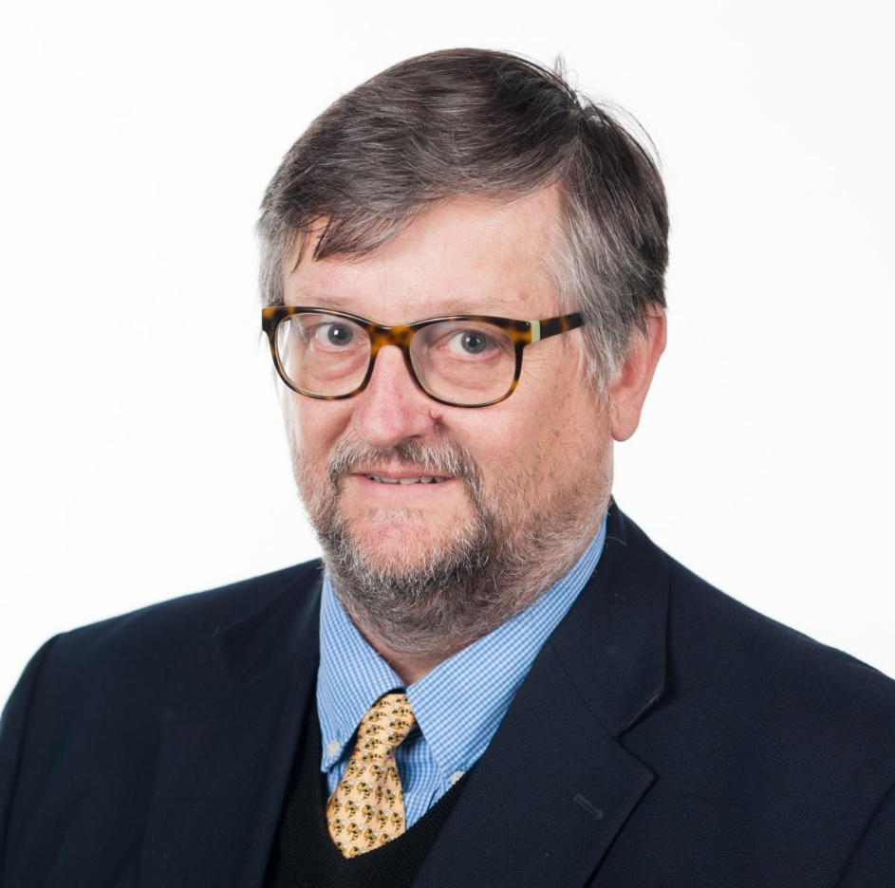
J. David Frost, B.A., B.A. I., Technical French, Mathematics, Civil Engineering, Trinity College, Dublin, Ireland; MSCE 1986 Purdue, Ph.D. Purdue, 1989, P.E., U.S. & Canada

Elizabeth & Bill Higginbotham Professor, Regents Entrepreneur
Professor, School of Civil & Environmental Engineering; Affiliated Professor, School of Computational Science & Engineering; Georgia Institute of Technology
Geosystems Engineering Group Leader and served as Vice Provost at Georgia Tech as well as the founding director of Georgia Tech at Savannah and the Regional Engineering Program. Dr. Frost was Major Advisor to 45 Ph.D. students including 20 that have gone on to academic careers and currently advises 12 Ph.D. and 12 MS thesis students. Editor/co-editor of 12 conference/workshop proceedings and author on over 100 refereed journal papers including 3 that won national/international awards. Dr. Frost has authored over 120 refereed conference papers including 4 selected as recipient/finalists awards. He has presented over 130 invited seminars/lectures. Participant in National Academy of Engineers symposium on Frontiers of Engineering. Participant/leader on NSF reconnaissance teams following earthquakes in Turkey, India, U.S. China, and Japan. Leader of NSF reconnaissance team at Ground Zero following 9/11 World Trade Center attacks. Dr. Frost is a life Member Fellow of ASCE

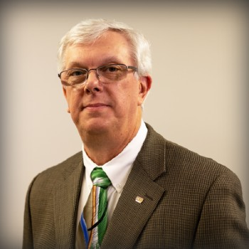

John Davis BSCE 1982, MSCE 1987, P.E., P.TOE, TSOS, RSP1(F)
President of the Institute of Transportation Engineers (ITE), 2024

John is City Traffic Engineer in Des Moines, IA, and has been an active member of ITE since he began his transportation career more than 35 years ago. He has held office in five Districts and Sections and has lent his leadership and expertise to several ITE Councils and Committees over the years. John has been an integral part of the success of ITE’s Annual Collegiate Traffic Bowl, leading its production for the past 13 years.
John is at least the 4th Purdue alumni to serve as an ITE international president, preceded by Laurence Dondanville in 1974; Professor Harold L. Michael in 1975; and James H. Kell in 1986.
Founded in 1930, ITE is a community of transportation professionals including, transportation engineers, transportation planners, consultants, educators, technologists, and researchers. Through meetings, seminars, publications, and a network of more than 17,000 members working in 78 countries, ITE connects you to a world of ideas, people, and resources.John was the 2015 recipient of ITE’s Burton W. Marsh Award for Distinguished Service and recognized for his distinguished service in the Florida and Wisconsin Sections and in the Midwestern District.
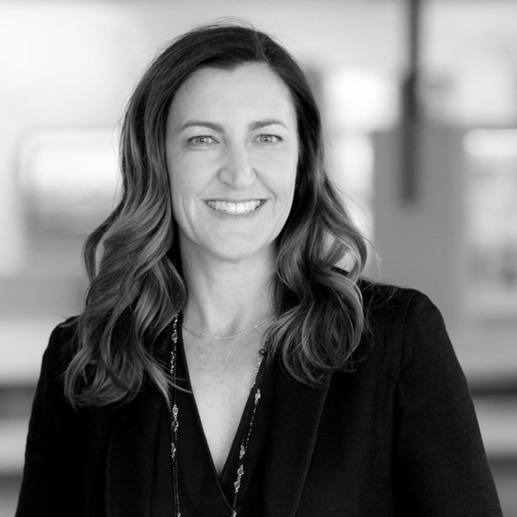
Amy Schumacher, B.A. 1993, BSCE 1997, Chief Executive Officer of the Heritage Group, Indianapolis, IN

The Heritage Group is comprised of more than 5000 employees and 30 business units. Amy has been part of the Heritage Group family of businesses for over 12 years. In 2008, she founded Monument Chemical, the group’s specialty chemical business and served as president for eight years. In that role, she was responsible for growing Monument Chemical from a small, Indianapolis-based business into a global company with operations in Europe and the U.S. In 2016, Amy transitioned to President of the Heritage Group and was appointed CEO in 2020. The Heritage Group R&D team’s broad accomplishments include more than 100 patents. It includes the launch of several new businesses. These include full recycling of used engine oil, better micronutrients for animals, high friction pavements for safer highways and streets, and new biobased lubricants that are biodegradable. Amy also has an MBA from MIT.

