Purdue CE 498 Senior Design Course Syllabus
Spring Semester 2025
(Revised 01/10/2025)
In consort with Kiewit, Inc., Omaha, NE
and
Weeks Marine Construction Engineering Company, Cranford, NJ

PROJECT TITLE: “Rebuilding the Francis Scott Key Bridge in Baltimore, MD Harbor”

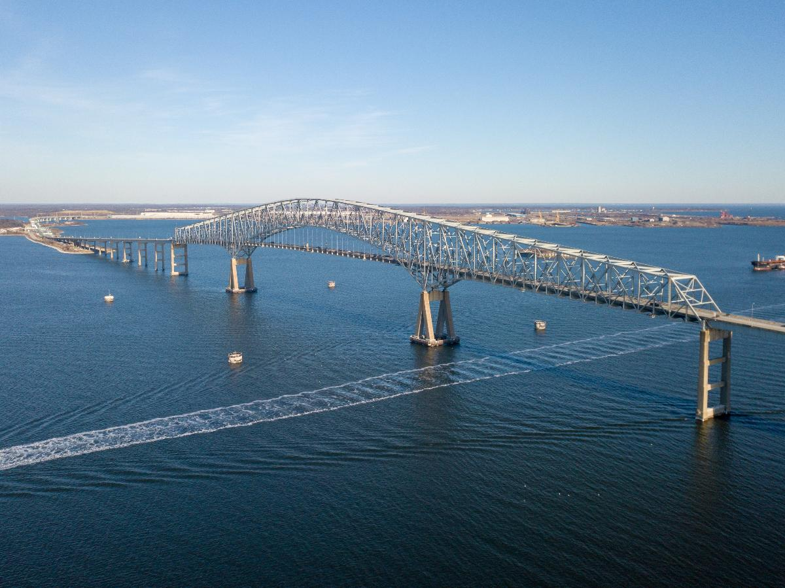
Francis Scott Key Bridge in Baltimore Harbor
March 25, 2024

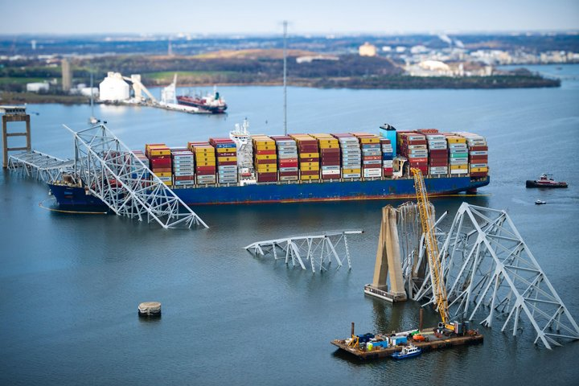
Francis Scott Key Bridge Following Collapse Due to Container Ship Impact, March 26, 2024
Background
The Baltimore Maryland harbor lies at the mouth of the Patapsco River which ultimately flows into Chesapeake Bay. In 1977 a continuous steel truss bridge, with a 366m span and a 2600m total length named the Francis Scott Key (FSK) Bridge was completed over the bay and served as the Interstate Highway link I-695 across the harbor. In the early morning hours of Tuesday, March 26, 2024, the 116,000-ton cargo ship ‘MV DALI’, leaving the harbor dock, lost engine power and began to drift toward the bridge with the flow of the river. Unable to restart its engines, the drifting, fully loaded cargo ship, headed toward one of the bridge piers supports the FSK bridge. Upon impact, the entire bridge span collapsed into the Patapsco River. Examination of the two graphics on the previous pages shows the before and after of the catastrophe. Six highway workers repairing the bridge were killed and the commerce from the docks ceased for eleven weeks while the debris was cleared from the harbor floor. Kiewit Engineering, Omaha, NB was awarded the contract for the bridge rebuild and have graciously agreed to collaborate with the Lyles School of Civil and Construction Engineering Senior Design Course, CE 49800, and their 15 engineering teams for the bridge rebuild.
Md. bridge rebuild to start with federal funding
The Maryland Transportation Authority will begin rebuilding the Francis Scott Key Bridge in January, with preconstruction activities starting Jan. 7 and demolition slated for spring. The $2 billion project is fully funded by a federal disaster relief package. Kiewit Infrastructure has received a $73 million contract for design and construction.
Full Story: Roads & Bridges (12/31)

Student Outcomes, re: ABET
2. An ability to apply engineering design to produce solutions that meet specified needs with consideration of public health, safety and welfare, as well as global, cultural, social, environmental and economic factors.
4. An ability to recognize ethical and professional responsibilities in engineering situations and make informed judgements which must consider the impact of engineering solutions in global, economic, environmental and societal contexts.
5. An ability to function effectively within a team whose members together provide leadership, create a collaborative and inclusive environment, establish goals, plan tasks and meet objectives.
7. An ability to acquire and apply new knowledge as needed, using appropriate learning strategies.

Engineering Teams: The class will be divided up into 15 engineering design teams with 11 to 12 members on a team. Each team will select a “project manager” and an “assistant project manager.” These 15 project managers and assistant project managers will meet on Tuesday each week, schedule permitting, in HAMP G212 at 9:30am to 10:00 am with Professor Jacko, and Teaching Assistants Juan Nicolas Villamizar and Phillip Shoopman, P.E. Please identify your project managers by Tuesday, January 21, 2025. Later, each team will be issued time sheets where you will be able to record your time and activity on the project for invoicing purposes.
Convey your team’s weekly activity statements and time spent to the nearest 0.5 hr. to the TA’s every Tuesday by 11:00am. Each team will also create a company name and appropriate logo to be used on all correspondence and will convey this information to TAS Juan and Phillip by Tuesday, January 28, 2025.

Team Challenges
Teams 1 – 15 will consider the rebuild of the Francis Scott Key Bridge over the Baltimore Harbor to nominally follow the original alignment of the bridge. The scope of the rebuild will include the east and west roadway approaches, the bridge superstructure typology, bridge roadway design and the relevant foundation design including pier protection considerations/designs. Critical decisions are the bridge span, drainage, overhead clearance, waterway depth, signage, nautical markers, and considerations of future maximum ship sizes 50 years hence.
Other General Considerations
- Incorporate the AADT for the bridge roadway.
- Consider future tidal effects.
- Delineate the construction zone staging area.
- Estimate labor and material costs including an appropriate contingency percentage
- Manage the construction activities using a GANTT CHART highlighting the lead items
- Delineate all necessary permits identifying the max lead time permit.
- Reference appropriate Codes.

Deliverables Phase I
The conceptual student designs will be delivered in two Phases. Phase I will be devoted to project familiarization, preliminary considerations and preliminary designs to include environmental, structural, geotechnical, geomatic, transportation, architectural, material specifications and hydraulic/hydrology issues. Preliminary cost analyses will also be included. This phase will culminate in a 25-minute formal engineering presentation and a 25-page formal engineering report. Each author will be clearly identified in each section of the report. Reports to be printed single-sided. Appendices to be bound with the report. YOUR TEAM NUMBER MUST BE PROMINENTLY DISPLAYED ON THE REPORT FRONT COVER, UPPER RIGHT-HAND CORNER, in 48-point font. In addition, each team will submit Weekly team task sheets (time sheets) and chapter summaries from CE design textbook by Choi on Tuesdays.

Deliverables Phase II
The final conceptual student designs will again relate directly to those topics in Phase I but will include far greater detail/calculations/dimensions than in Phase I. Both a 20-minute formal presentation and 25-page report will also be delivered. Appendices to be bound with the report. Reports to be printed single-sided. YOUR TEAM NUMBER MUST BE PROMINENTLY DISPLAYED ON THE REPORT FRONT COVER, UPPER RIGHT-HAND CORNER, in 48-point font. In addition, each team will submit weekly team task sheets and chapter summaries from CE design textbook by Choi.
Purdue Writing Lab tutors available
Last Updated August 17, 2017, 2:40pm
Schedule appointments at http://cla.purdue.edu/wlschedule.

Required Text: Principles of Applied Civil Engineering Design, 2nd edition by Choi, Ying-Kit, ASCE Press, 2017 stock number=40712, ISBN 0-7844-0712-6. This book has 25 chapters. The book is free through the ASCE Journal and can be accessed in pdf format through the Purdue library database (https://www.lib.purdue.edu/).
Suggested reference text: The Civil Engineering Handbook, Chen & Liew, CRC Press
Weekly reading /writing assignment: Each week a one-paragraph written summary for each chapter must be submitted in hard copy for the following chapters in the Choi textbook. The summary must include a reflection on what you found most personally interesting. All summaries must be held to one page and are due on the dates listed below:
Due Date Chapters
01/21/25 1,2
01/28/25 3,4
02/04/25 5,6
02/11/25 7,8
02/18/25 9,10
02/25/25 12,13 (skip chapter 11)
03/04/25 14, 15
03/11/25 16, 17
03/17-22/25 Spring Break Week
03/25/25 18,19
04/01/25 20, 21
04/08/25 22, 23
04/15/25 24, 25

CE 498 Personnel:
Kiewit Engineering, Inc
Jim Rowings, Ph.D., P.E. jim.rowings@Kiewit.com

John Hillman, P.E. Chief Bridge Design Engineer John.Hillman@Kiewit.com

Purdue University, Lyles School of Civil Engineering:
Prof. Robert Jacko, Ph.D., P.E course director jacko@purdue.edu

Teaching Assistants:
Juan Nicolas Villamizar, Ph.D. Student, Structures jvillam@purdue.edu
Phillip Shoopman, P.E., Ph.D. Student, Environmental pshoopma@purdue.edu

And the entire CE faculty is available for consultation.

Assigned Design Rooms and Expected Hours of occupancy:
Entire class: FRNY G 140, 8:30 a.m. to 9:20 a.m. Tuesday and Thursday
Teams 1,2,3 HAMP 2101, 9:30 to 11:20 a.m. Tuesday and Thursday
Teams 4,5,6 HAMP 2108, 9:30 to 11:20 a.m. Tuesday and Thursday
Teams 7,8,9 HAMP 2113, 9:30 to 11:20 a.m. Tuesday and Thursday
Teams 10, 11,12 HAMP 2123, 9:30 to 11:20 a.m. Tuesday and Thursday
Teams 13, 14,15 HAMP 3153, 9:30 to 11:20 a.m. Tuesday and Thursday

Note: (a) These same office hours also apply to the Olson Design Lab in room 3154 for all teams. (b) Each team is required to meet in the above-mentioned design rooms from at least 9:30am-10:00am on Tuesdays and Thursdays when the instructors make the initial rounds.

Grading:
Chapter summaries: 5%
Presentation Procedures and grading: Phase I: Each team will select 5 members to make the oral presentation to the owners and observers (faculty and students). The non-speakers will locate also to the front of the Beck Center conference room adjacent to the five speakers. The five speakers will have a maximum of 25 minutes for their presentations and immediately following the presentations there will be a 10 minute Q & A session for owners and observers. Questions must be directed to a speaker who then must redirect the question to one of the non-speaker team members and the speaker can use discretion during this non-speaker answer period. The final score for that speaker is affected by the answer to the question. The team will be scored at the end of its presentation and each speaker’s score will be averaged against the team score. The five averaged speaker scores will then be assigned to all team members. For Phase II, speakers must be rotated.
Written Report Procedures and grading, Phase I and II: Authors of sections in the report must be identified with their last names shown in the section title.
Phase I: Preliminary Engineering Report - written report 20%, oral presentation 15%. Appendices to be bound with the report. YOUR TEAM NUMBER MUST BE PROMINENTLY DISPLAYED ON THE FRONT COVER OF THE REPORT in 48-point font in the upper right-hand corner.
Phase II: Final Conceptual Design Report - written report 40%, oral presentation 20%. Appendices to be bound with the report. YOUR TEAM NUMBER MUST BE PROMINENTLY DISPLAYED ON THE FRONT COVER OF THE REPORT along with the Project Title and date.
Final Grading: The overall course grade will be the weighted average of chapter summaries (5%), Phase I (35%) and Phase II (60%).
Attendance and I-Phones: Attendance by all is required at the first lecture hour on Tuesday and Thursdays when the use of I-Phones is prohibited (during the lecture hour), as it is highly disrespectful to the guest speakers. Also, there is no phone usage during the 3 hour-long formal engineering presentation sessions culminating in Phase I and II. For the remaining two hours of design lab each Tuesday and Thursday, you are expected to be working with your team. The penalty for an unexcused absence will be removal of one point from your final course average grade for each unexcused absence. If you would like to be excused for a legitimate reason (illness, job interview, conference, etc.), email Prof. Jacko and TAs Phillip Shoopman and Juan Nicolas Villamizar prior to the class you want to be excused from and state the reason.
Check regularly the latest syllabus, class presentations, and other class related information.
OneDrive: Additional information on our project will be posted on a shared folder.
(***) You will receive an email with a link on how to access the shared folder (use your Office 365 account).
Begin reading about the Project, its history, existing technical condition and become familiar with the data regarding the site. Visit the following link below:
CE 498 Students

CALENDAR: Phase I
Note: The following calendar dates and times are subject to change. You will be notified in advance of these changes.
Phase I: Preliminary Engineering Report (note: all the following classes begin at 8:30am in FRNY G140 and then proceed to your assigned HAMP lab rooms for the remaining two. Oral engineering team presentations all begin at 8:00 am.

Date Activity
01/14/25 Tu 8:30am classroom FRNY G140 Personnel introductions; Julie Jesiek, Senior Undergraduate Advisor will discuss graduation requirements; Project Introduction: The Francis Scott Key Bridge Rebuild, Baltimore, MD Harbor; Team assignments; University Emergency Safety Instructions. Julie Jesiek confirmed, 12/17/2024

01/16/25 Th 8:30 to 9:20am. James E. Rowings, PE, Ph.D., NAC, Vice President of Kiewit University, at Kiewit Corporation Construction Company to discuss how to collaborate in teams and to address engineering aspects of the Francis Scott Key Bridge Rebuild Project. Confirmed Nov 2024
01/21/25 Tu Professor Brandon Fulk to explain CE career placement opportunities; Introduction of Teams Project Managers, Assistant Project Managers, company logos and company names. Each project and assistant project manager will address the class and give a short, autobiographical sketch.
Project Managers and Assistant Project Managers meeting G212 9:30 to 10:00am

01/23/25 Th 8:30am Ron Klemencic, P.E., S.E., Hon. AIA, NAE, Chairman & CEO, Magnusson Klemencic, Associates, Seattle and Chicago to address our senior design teams emphasizing the importance of in-house team collaboration and innovative design. Confirmed 11/05/2024
01/28/25 Tu Professor Dennis Lyn from the Purdue Hydraulics Specialty Area to discuss the bridge drainage, pier scour considerations and other hydraulic aspects of our project. Not Confirmed
01/30/25 Th John Hillman, P.E., Chief Bridge Designer, Kiewit Corporation Construction Company to discuss the FSK bridge rebuild. Confirmed 12/05/2024
Project Managers and Assistant Project Managers meeting G212 9:30 to 10:00am
02/04/25Tu Professor Paul Giroux, Veteran builder and award-winning civil engineering historian to share his unique perspective of the great projects and the timeless lessons of the builders of the great projects. Confirmed
02/06/25 Th Zhengzheng Jenny Fu, P.E., Principal Design Engineer, Kiewit, Corporation Construction Company, BIM/digital considerations. Confirmed 12/11/2024
02/11/25Tu Mike E. Winters, P.E., of Moffatt & Nichol, Raleigh, NC to discuss vessel collision protection for waterway bridges. Pending Confirmation, 12/17/2024
02/13/25 Th Professor Jacko to discuss the finer points on giving power point presentations, report writing, and binding/organization requirements. Team design summary statements due today: 250 words describing your team’s management strategy.
Project Managers and Assistant Project Managers meeting G212 9:30 to 10:00am
02/18/25 Tu 8:30am Class Photos: G212 Conference room. Individual class photos will be taken so business dress is required, i.e., suits, ties, etc. Ms. Jaimee Barr will give you the details as to the exact times etc.
02/20/25 Th Professor Amit Varma of the Purdue Structural Group to discuss the use of “SpeedCore” modules for bridge tower construction. Not Confirmed

02/25/25 Tu Phase I Oral Presentations will begin at 8:00 am at the Beck Agricultural Center on HWY 52 West
Procedure: Following each team’s presentation, the 10 minute Q & A session will begin. Owners and Observers will participate. Location: BECK Agricultural Center on Hwy 52 West.
02/25/25 Tu Teams 1, 2, 3, 4, 5 Each team has 25 minutes for the presentation and 10 minutes for questions from the faculty and students. All team members must be present. All observing teams and their members are required to attend. Beck Ag Center Hwy 52 west.
02/27/25 Th Teams 6, 7, 8, 9, 10 Each team has 25 minutes for the presentation and 10 minutes for questions from the faculty and students. All team members must be present. All observing teams and their members are required to attend. Beck Ag Center Hwy 52 west.
03/04/25 Tu Teams 11,12,13,14,15 Each team has 25 minutes for the presentation and 10 minutes for questions from the faculty and students. All team members must be present. All observing teams and their members are required to attend. Beck Ag Center Hwy 52 west.
03/06/25 Th Phase I Written reports due from all teams at 11:00 am in the Olson Lab. Report to be submitted in three (3) paper copies and one digital copy (25 pages max single-sided, appendices to be bound in a separate rear section of the report). No formal meeting.

CALENDAR: Phase II Begins
Begin Phase II Tuesday, March 11, 2025
03/11/25 Tu Nico Villamizar our TA will discuss the structural aspects of bridge design.
03/13/25 Th Professor Rodrigo Salgado of our Geotechnical Engineering Group to discuss the design and use of piles for our site. Not Confirmed
03/17-22/25 Spring Break

03/25/25 Tu 8:30am Jim Rowings of Kiewit to address questions on the FSK Bridge rebuild. Confirmed 12/06/2024
Project Managers and Assistant Project Managers meeting G212 9:30 to 10:00am03/27/25 Th Phillip Shoopman will discuss the environmental engineering aspects of our project.
9:30 Professor Robert Jacko, Phillip Shoopman and Juan Nicolas Villamizar will be in the Olson Lab with your graded reports and feedback. Team managers come to the lab and bring the reports and feedback to their teams in the respective design classrooms. Then during rounds we will answer questions.
04/01/25 Tu Postdoc Researcher on pavements from Professor John Haddock’s staff, Dr. Mohammad Ali Notani will discuss bridge deck pavements. Confirmed 12/20/2024
04/03/25 Th CEAAA Day 8:30am, Civil Engineering Alumni Achievement Awards. All students meet as normal in FRNY G140 to meet and find out how our honored alums became so successful.
04/08/25 Tu Professor Jacko to discuss Professional Engineering Licensure an Ethics case history involving the ASCE Code and final presentations, reports and the “Comma.”
04/10/25 Th Professor Brandon Fulk of the Purdue Construction Engineering Management Division to discuss Construction techniques/costing which will be utilized on this project. Confirmed, 12/17/2024
04/15/25 Tu 8:30am, Claude Goguen, P.E., LEED AP, Director of Sustainability and Technical Education National Precast Concrete Assn. , Indianapolis to discuss the use of precast structural elements for the FSK bridge. Not Confirmed
Project Managers and Assistant Project Managers meeting G212 9:30 to 10:00am

04/17/25 Th No formal guest lecture hour. Work in teams to put the finishing touches on your Phase II presentations.

04/22/25 Tu Phase II Engineering Presentations Begin, 8:00am at the Beck Agricultural Center on HWY 52 West
Procedure: Following each team’s presentation, the 10 minute Q & A session will begin. Owners and Observers will participate. Location: BECK Agricultural Center on Hwy 52 West.
04/22/25 Tu Teams 11,12,13,14,15. Each team has 25 minutes for the presentation and 10 minutes for questions from the faculty. All observing teams and their members are required to attend.
04/24/25 Th Teams 6,7,8,9,10. Each team has 25 minutes for the presentation and 10 minutes for questions from the faculty and students. Location: All observing teams and their members are required to attend.
04/29/25 Tu Teams 1,2,3,4,5. Each team has 25 minutes for the presentation and 10 minutes for questions from the faculty and students. Location: All observing teams and their members are required to attend.
05/01/25 Th 11:00am. Final class meeting in the Olson Lab, HAMP 3154. Prof. Brandon Fulk will present information on filling out your exit survey, also-------
Written reports due from all teams. Report to be submitted in three (3) paper copies double spaced, single-sided and a digital copy of the report. (25 pages max, appendices to be bound in a separate rear section of the report). Page 26 will contain the reference list.
In the event of a major campus emergency, course requirements, deadlines and grading percentages are subject to changes that may be necessitated by a revised semester calendar or other circumstances. For more information send an email request to jacko@purdue.edu

