CE 65000-001 (CRN = 31042, MWF 1:30-2:20 PM, HAMP 2113)
CE 69700-EPE (CRN = 32630, Online)
Photochemical Reactors: Theory, Methods, and
Applications of Ultraviolet Radiation
Instructor: Ernest R. Blatchley III (blatch@purdue.edu)

Additional information about this class can be found online at: https://sswis.mypurdue.purdue.edu/CourseInsights/content/showCoursePage/3432

Photochemical, photobiological, and photophysical processes are initiated by photon absorption. As such, the mechanisms of these processes are fundamentally different than processes that involve thermal chemical reactions or biochemically-mediated reactions. This allows photon-based processes to achieve chemical or microbial transformations that are often faster and far more efficient than their (thermal) chemical and biochemical analogs. Photochemical reactions also play critical roles in natural systems.
The scientific principles and tools that are used to understand photochemical reactor dynamics have matured over the last 20-30 years. These principles now form the basis for design of photochemical reactors and for interpretation of natural photochemical processes. With these facts in mind, a new course has been developed to provide comprehensive coverage of the principles that govern the behavior of photochemical reactor systems, whether they are “engineered” or exist as natural systems. This course was developed as a graduate-level class for students in engineering and the physical sciences.
Important examples of photochemical or photobiological processes are presented below.

Disinfection of Water and Wastewater: UV-C radiation is highly effective for inactivation of microorganisms, including virtually all bacterial, viral, and protozoan pathogens that are found in water. UV disinfection of water, wastewater, and other aqueous media has emerged as an important alternative to conventional disinfection processes, which historically have been based on chlorination. UV disinfection processes are more effective than chlorine-based processes for inactivation of many waterborne pathogens, while at the same time requiring less energy and a smaller footprint to meet common treatment objectives. For some waterborne microbial pathogens, such as the protozoan parasites Cryptosporidium and Giardia, UV-based processes are essentially the only treatment process that can achieve effective control, at least when practical constraints regarding energy and environmental effects are considered. | 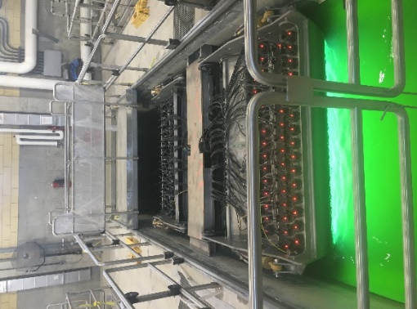  UV disinfection system at the O’Brien wastewater treatment facility in Chicago, IL.
Direct Photolysis: Some water contaminants are recalcitrant to conventional treatment methods. A prominent example is the compound N-nitrosodimethylamine (NDMA), which represents a common water contaminant and extremely potent carcinogen. NDMA is difficult to treat using conventional transformation and separation processes. However, it is effectively degraded by exposure to UV radiation. Similar behavior is evident for other common water contaminants. Similarly, UV-based photolysis can play important roles in chemical synthesis. | Primary photochemical reaction associated with UVC photolysis of NDMA.
Ultraviolet Advanced Oxidation Processes (UV AOPs): Primary photochemical reactions often involve cleavage of covalent bonds, resulting in formation of radical intermediates; of particular interest are processes that lead to formation of the hydroxyl radical $\left(HO∙\right)$ and the chlorine radical $\left(Cl∙\right)$. In turn, these radical intermediates can open reaction pathways that would otherwise be unavailable. This behavior is often exploited in processes to facilitate degradation or transformation of compounds that are difficult to accomplish using conventional chemical or biochemical processes. | $$H_{2}O_{2}\underset{→}{hν}2HO∙$$  $$HOCl\underset{→}{hν}HO∙+Cl∙$$  $${NH}_{2}Cl\underset{→}{hν}{NH}_{2}∙+Cl∙$$  Examples of primary photochemical processes for formation of oxidizing reactive intermediates.
Ultraviolet Advanced Reduction Processes (UV ARPs): Primary photochemical reactions can also lead to formation of radical intermediates that function as powerful reducing agents, especially focused on production of hydrated electrons $\left(e_{aq}^{-}\right)$. Processes that follow this approach have been demonstrated to be effective for degradation of recalcitrant, highly oxidized compounds, including PFAS (i.e., “forever chemicals”). | $${SO}_{3}^{2-}\underset{→}{hν}{SO}_{3}^{∙-}+e_{aq}^{-}$$  $${HSO}_{3}^{-}\underset{→}{hν}{HSO}_{3}^{∙}+e_{aq}^{-}$$  Examples of primary photochemical processes for formation of reducing reactive intermediates.
Disinfection of Air and Surfaces: Disease transmission in indoor spaces is often associated with aerosolized viruses and bacteria. UV-C radiation is effective for inactivation of virtually all airborne and surface-associated microbial pathogens. UV-based processes have been demonstrated to be more effective than other engineering control measures that can be used for reduction of human exposure to aerosolized pathogens, while also having lower energy and carbon footprints than other process alternatives. | 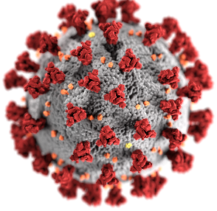

About the Course
This course will provide comprehensive coverage of the principles that govern photochemical reactor behavior. The course begins with a presentation of the historical foundations of photochemistry and photochemical reactors. It continues with presentations of the fundamental theories that explain photochemical reactions and the dynamic behavior of photochemical reactors. The fundamental physics that govern the behavior of sources of ultraviolet (UV) radiation are then presented. Numerical and experimental methods that are used to characterize, quantify, and validate the performance of photochemical reactors are then explored. The course concludes with examinations of the most common applications of UV radiation, including disinfection of water and wastewater, direct photolysis, advanced oxidation and reduction processes, and UV disinfection of air and surfaces.

Course Goals/Learning Objectives
Students will learn fundamental principles of photochemistry and photochemical processes that are in common use. These fundamental principles will be used as a foundation to explore the behavior of photochemical reactors and methods used to evaluate and predict their behavior, including analytical and numerical methods. Applications of UV radiation will be explored, including disinfection of water and wastewater; chemical transformations by direct photolysis, photooxidation, and photoreduction processes; and disinfection of air and surfaces. The focus in this class will be on fundamental concepts, so as to prompt their application in a wide range of settings, encourage questions and discussion, and to promote creativity. It is anticipated that the course will include students from a wide range of geographic and experience backgrounds. The course will be conducted in a manner that promotes exchange of ideas from people in different locations and with different backgrounds.

