Tech Talk
with

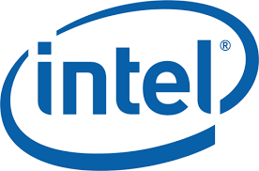

Learn About Opportunities for
MS and PhD Students

When: Monday, Feb. 6th
Time: 5:00pm – 6:30pm
Location: 1001 Birck Nanotechnology Center

STUDENTS - Join Intel Corporation representatives for a Tech Talk and learn about the exciting opportunities for MS and PhD students pursuing a degree in EE, ECE, ChemE, Physics, Chemistry, Material Science, and more! Food Provided!

