BNC Strategy on Biosafety Cabinets

Fume Hoods, Biosafety Cabinets and Clean-Air Devices
Fume hoods, biosafety cabinets, and clean-air devices are often lumped into an overall category of “hoods,” while each of these devices has a specific purpose with entirely different functionality. Within each of these general categories, there are subcategories – leading to even more confusion.
Without an understanding of how each of these devices function, it would be easy to select the wrong device for the intended purpose. This could lead to safety issues, environmental concerns, unnecessary expense, and/or problems with sample contamination and lost research. The following notes provide basic information on the function of these devices and their intended use.

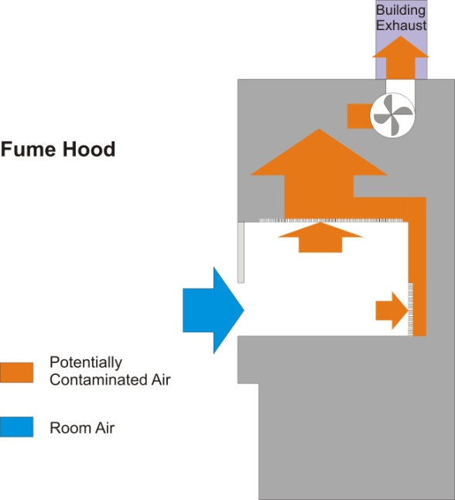
Fume Hoods are devices that provide containment and exhaust to protect the user during operations where hazardous gases, vapors, or fumes may be present. Fume hoods do not provide containment for biological materials exhausted from the hood, and therefore may not be used for work with pathogenic materials. They are intended for use with acids and solvents if no pathogenic materials are involved.
There are two general types of fume hoods, those that provide clean air to the sample and those that provide only exhaust. Both types provide protection for workers and protection for the environment for chemicals and gases, but only those that provide clean air provide any protection for the product.
Fume hoods are specified for use with acids OR solvents, but may not be used with both classes of material.

Biosafety Cabinets are designed for use with biological materials, including pathogenic materials. All biosafety cabinets provide a HEPA filter on the exhaust of the cabinet, thus capturing biological materials and preventing their release into the atmosphere. Some, but not all, biosafety cabinets are designed for use with volatile and/or hazardous chemicals as well as biological materials.
Class I biosafety cabinets provide protection for personnel working with biological agents and protection for the environment, but do not provide product protection. Air is exhausted from the enclosure through a HEPA filter, but air input is from the laboratory.
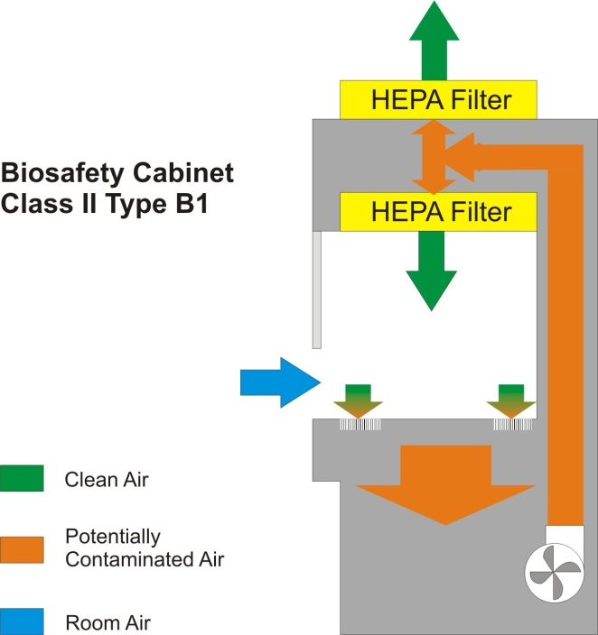
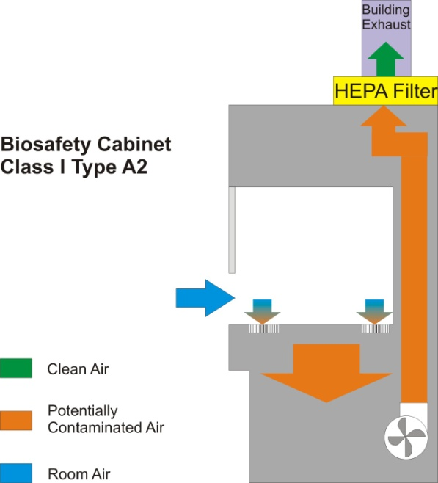
Class II biosafety cabinets provide protection to workers, environment, and product. They provide a HEPA-filtered air input into the cabinet for product protection as well as a HEPA filter on the cabinet output.
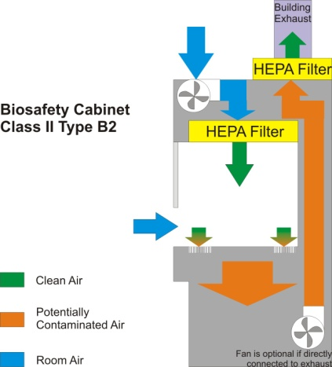
Type A1 and A2 biosafety cabinets are not connected to the building exhaust system, and therefore may not be used with volatile and/or hazardous chemicals. These cabinets have a recirculating air system with approximately 70% of the air recirculated within the cabinet through a HEPA filter and 30% of the air released into the room through a separate HEPA filter.
Type B biosafety cabinets must be hard-ducted to an exhaust system. Types B1 and B3 recirculate a portion of the air back into the work zone of the cabinet, and therefore may not be used with volatile and/or hazardous chemicals. Type B2 cabinets exhaust 100% of the air from the cabinet and therefore may be used with small quantities of volatile and/or hazardous chemicals. Please note that a Type B biosafety cabinet is NOT a substitute for a fume hood.
Class II Type B2 cabinets may be purchased with a single fan which supplies clean air over the product or with two fans, one to circulate clean air over the product and one to overcome the static-pressure drop across the exhaust HEPA filter.

Clean Air Stations, sometimes called laminar airflow stations or unidirectional airflow stations, provide protection for the product, but do not provide protection for the operator or the environment. In fact, these stations blow air directly toward the operator and the room. For this reason, these stations may not be used for pathogenic materials, volatile chemicals, or hazardous chemicals.
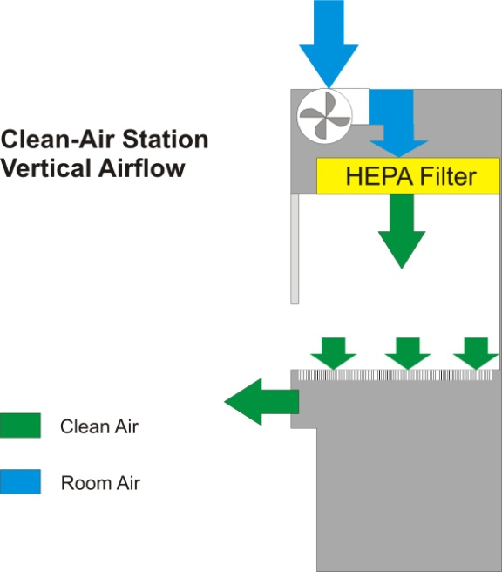
There are two major types of clean-air station: horizontal airflow and vertical airflow. As implied by the name, a horizontal-airflow clean-air station has a HEPA or ULPA filter mounted at the rear of the enclosure, and clean air is blown horizontally toward the operator. In this type of station, no materials that could generate contaminants should be located between the rear of the station and the product. A vertical-airflow clean-air station has a HEPA or ULPA filter mounted horizontally at the top of the enclosure, with clean air blown down across the top of the product, generally exiting through a perforated or grated work surface. A hybrid station has a top-mounted filter with the air exiting through an opening facing the operator. In both the vertical-airflow and hybrid station, no potentially contaminating materials may be placed above the level of the product.

BNC Strategy
The current BNC strategy is to recommend the purchase of Class II Type B2 cabinets for all pathogenic (BSL-2) work, as a significant amount of this work involves the use of solvents. There may be cases, however, where specific areas require pathogenic work but not volatile or hazardous chemicals are – nor will be – used. In these cases, it may be more practical to purchase a Class I or Class II Type A cabinet – depending on product-protection needs.
Please discuss any intended fume-hood or biosafety-cabinet purchases with the BNC staff, as these enclosures have a direct impact on the building exhaust systems. It is critical that building exhaust be taken into account, even in cases where a biosafety cabinet is not hard-connected to the building exhaust.
Currently the Class II Type B2 biosafety cabinets purchased are of the single-fan type. This requires a significantly higher exhaust static pressure in the building exhaust system to overcome the differential pressure of the HEPA filter. With the current exhaust upgrade project, we have adequate differential pressure for all current and planned future biosafety cabinets. It may become necessary, however, to require purchase of two-fan systems as the number of biosafety cabinets increases. This will be dealt with on an individual basis as the facility grows.

John R. Weaver
8 January 2013

