Proposed faculty for Colombia-Purdue Institute for Advanced Scientific Research (CPIASR)
Dear Faculty Partner:
We are excited about your participation in this important program. We have included below a sample profile that can best communicate to both Colombian students and faculty about your research programs and interests. Colombian students seeking to apply to PhD programs at Purdue University will need to access this information to facilitate a match. This is an important step in their application to the Colciencias Jose Caldas 5-yr PhD Fellowships. Also the page can serve for contact with Colombian faculty, who can also help in identifying top Colombian student applicants.
Please fill out the information using the sample format below to: Mary Nauman grants@marynauman.com. We would prefer a profile “head shot” photo to place it next to your information. In addition, we ask that you include both your “research interests” as well as “research projects”. The latter means those projects currently funded.
Faculty information
Dr. Jeffrey Youngblood,
Associate Professor,
School of Materials Engineering
Email: jpyoungb@purdue.edu
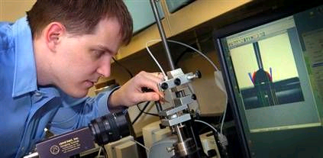Website: https://engineering.purdue.edu/MSE/People/Faculty/jpyoungb/index.html
Research interests and projects
Cellulose Nanotechnology : high strength cellulose nanocrystal films via orientation by shear-casting, Laminated nanofibrillated cellulose composites, Dynamic mechanical behavior of cellulose nanocomposites, Gas permeability of cellulose nanocrystal films, Nanocellulose additives for cement, Nanofibrillated cellulose spun nano- and micro-yarns.
Composites: UV-cured vinyl ester/fiberglass patches for rapid patching of carbon fiber composites. Delayed onset UV-cationic epoxy resins for VARTM repair of carbon fiber composites. Enhanced transparency in fiberglass composites
Surface Modification, Wettability, and Coatings: Self-cleaning oleophobic, hydrophilic surfaces and coatings, Superhydrophobic surfaces, Fundamentals of wetting, Phosphate-based polymer surface treatments.
Functional Polymers: Antimicrobial polymeric biomaterials
Advanced Ceramics processing: Ultra-high temperature ZrB2 ceramic processing via ceramic suspension gel casting, Shear-thickening high volume content composite ceramic gels, Electrospinning of nitride and carbide ceramic nanofibers
Renewable and Green Polymers: Lignin based materials

