MARCH 11, 2021 PROJECT MANAGEMENT/TEAMWORK WEBINAR ABSTRACT

As graduate students, we can increase our level of success relating to research and developing projects by applying proven steps of project management. This is also important experience for future projects in our professional working careers. This can be accomplished by applying both technical and organization skills and using proven steps to develop outstanding project results. For larger projects, we need to apply additional non-technical skills as we participate effectively as part of a team. One of the best ways to advance our career is by demonstrating how we can work successfully with others.

This webinar, based on the experience of a practicing professional engineer, will provide an overview of both project management and teamwork principles that are easy to use and that have proven to be the best way to plan and implement successful projects. It includes a brief self-evaluation exercise to be completed before the webinar. Additional details relating to the webinar topics will be available in a document to be downloaded following the presentation.

Jim Watson, PE
President, WATSON ASSOCIATES
1280 Deer Run - Mansfield, Ohio 44906-3477
Cell: 419.565.3723 j.watson@ieee.org http://www.linkedin.com/in/watsonassociates

Jim received a Bachelor's Degree in Electrical Engineering from Purdue University in 1958, completed post graduate engineering courses at Youngstown State University, and is a graduate of the Executive Management Program at the University of Michigan. He is a Registered Professional Engineer, an IEEE Life-Senior Member, and a Student Professional Development Program National Speaker.

Following a 36-year engineering and management career with Ohio Edison Company, Jim took advantage of an early retirement opportunity and established Watson Associates to provide programs to incorporate non-technical skill development within existing university engineering technical classes. Watson Associates has directed the use of this program for more than 26,000 students at 14 major engineering universities.

Jim’s IEEE volunteer work with students started in 1975 at Youngstown State University and the University of Akron. He became an IEEE National Speaker in 1982 and joined Larry Dwon on the Student Awareness Task Force to develop Student Professional Awareness Conferences (S-PACs).

Jim received numerous awards from IEEE in recognition for his volunteer activities including the USAB Citation of Honor, USAB Professional Achievement Award, IEEE Third Millennium Medal, RAB Innovational Award, IEEE-USA Citation of Honor, and Robert S. Walleigh Distinguished Contributions to Engineering Professionalism, the highest IEEE-USA award for volunteer activities.

In 2011, IEEE-USA established the “IEEE-USA Jim Watson Student Professional Awareness Award”
https://ieeeusa.org/volunteers/awards-recognition/professionalism-awards/watson-award/ to recognize key individuals for their contributions to Student Professional Awareness Achievement Activities in the United States. This award has been received by 9 outstanding volunteers to date.

Jim is co-author, with Dr. Charles Alexander, of “Engineering Skills for Career Success” published by McGraw-Hill. This textbook is designed to help engineering students develop and enhance non-technical skills. He has also published 24 articles on career development in Frontiers in Education, IEEE Antennas & Propagation, IEEE Potentials, IEEE Women in Engineering, HKN Bridge, and Wireless Systems Design.
Jim has delivered more than 2,200 presentations in the United States, Canada, Europe, and Asia to a total audience of over 110,000. This includes 75,000 students at 203 different universities who attended 476 IEEE Student conferences and workshops and 913 additional student meetings. Jim was a speaker in 5 conferences at Purdue since 1989.

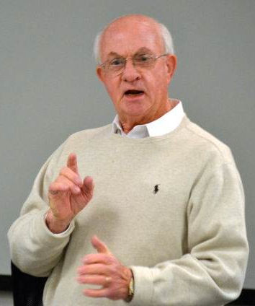
DETERMINING YOUR “DISPOSITION” IN A PROJECT MANAGEMENT TEAM

Place a “1” for all traits that represent what you typically do well in a team or group situation.

PART “D” PART “I”

Making things happen Interacting with others
Recognizing accomplishments Making good first impressions
Accepting challenges Being comfortable in expressing ideas
Making decisions Getting excited about a project
Questioning the "status quo" Instilling enthusiasm
Taking responsibility Entertaining people
Causing trouble Helping others
Solving problems Actively participating in a group
Visualizing the future Talking more than listening
Taking charge in difficult situations Not worrying about details

PART “S” PART “P”

Using established work procedure Following standards
Staying in one physical place Concentrating on details
Showing patience Being supervised by others
Using specialized skills Being diplomatic
Concentrating on your part of project Looking for accuracy
Showing loyalty Accepting decisions
Being a good listener Criticizing performance
Calming excited people Thinking critically
Being sincere and honest Liking familiar work situations
Wanting to feel secure Receiving compliments for good work

SUMMARY OF YOUR DISPOSITION RESULTS: TOTAL PART “D”

TOTAL PART “I”

TOTAL PART “S”

TOTAL PART “P”

