Seminar
School of Health Sciences
College of Health and Human Sciences

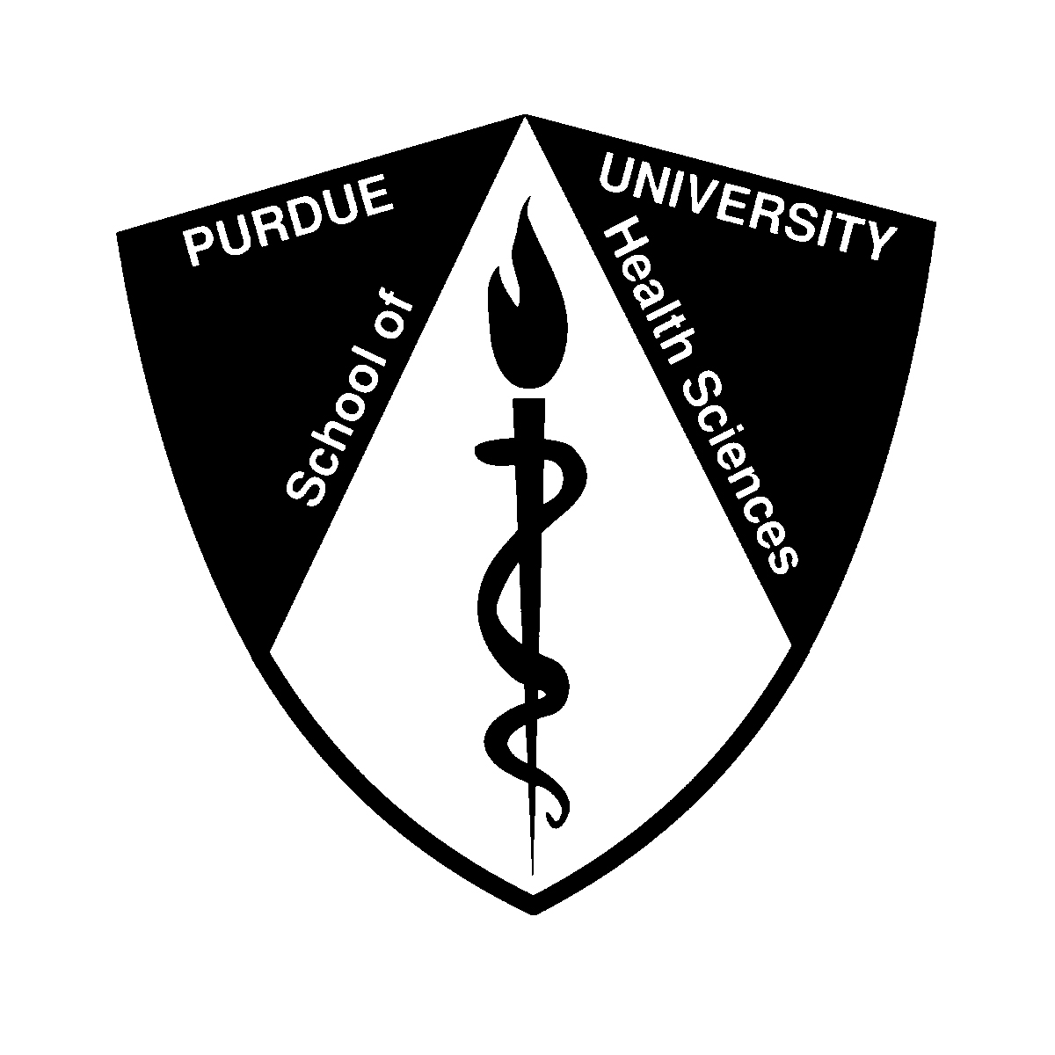

“What We Know and Don’t Know About
the Toxicity of Nanomaterials:
Challenges in Developing Experimental Approaches for Safety Assessment”

Peter Goering, Ph.D.
Toxicologist
Center for Devices and Radiological Health
U.S. Food and Drug Administration

Tuesday, September 28, 2010
CIVL 1252
4:30 p.m.

Host: Dr. Wei Zheng, Professor and Head, School of Health Sciences

