

Product Show

Lunch Provided

Where: Bindley Biosciences, Conference Room, 1st Floor

When: Wednesday, March 14th
12:00 PM to 1:30 PM

Learn about new products and promos
Meet your Fisher Scientific Team



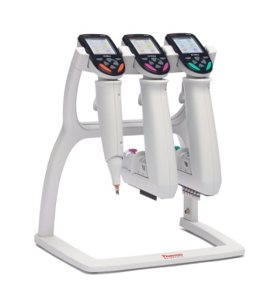

If you have any questions, please contact

Fisher Scientific representative Kevin Peterson at kevin.w.peterson@thermofisher.com or 317- 413-8747

