SEMINAR NOTICE
Birck Building, Room 1001
10:00AM

Exploring Multidisciplinary Discussions:
"Structuring international collaborative network for development of future reliability engineering physics on multi-phase interfaces and the physical system"

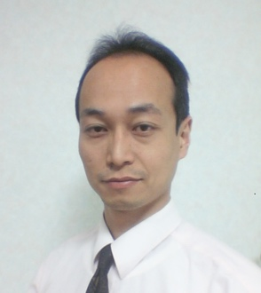
- KOJI ERIGUCHI, Professor
Department of Aeronautics and Astronautics, Kyoto University
Kyoto daigaku-Katsura, Nishikyo-ku, Kyoto 615-8540, JAPAN
“Plasma–solid interactions and its nano-scale evaluation techniques”
Understanding plasma–solid is of great importance for industrial and space applications. Low pressure plasma processing has been now widely employed in the field of nanotechnologies, in particular, the leading-edge electronic device manufacturing. Material surfaces exposed to plasmas (~ 5 nm thick) are suffering from the generation of defects due to high-energy ion bombardments and charge-up damage, which leads to the degradation of designed performance and reliability lifetime. This talk covers these mechanisms with an emphasis placed on plasma-induced damage (PID) in advanced electronic devices (the PID range theory), and discusses how we should quantify and design PID for realizing advanced plasma processes and highly reliable materials (e.g., boron nitride) implemented into space technologies in future.

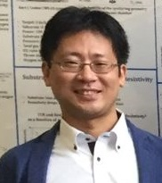
- KAZUYA TATSUMI, Associate Professor
Department of Mechanical Engineering and Science, Kyoto University
Kyoto daigaku-Katsura, Nishikyo-ku, Kyoto 615-8540, JAPAN
“Micro-Transport with Microfluidics”
Microfluidics have innovated various application in terms of miniaturizing the system, reducing the measurement time and cost, and enhancing the accuracy, and have made a large contribution to the fields of chemistry, heat transfer, medicine and biology. One important phenomenon in microfluidics and related micro-devices is the transports of mass, heat, chemical components and micro-scale objects which can be enhanced, suppressed and controlled with high accuracy due to the scale effects. We have been working on developing microfluidic devices that can control the transport phenomena in and by the microchannel flow. In this talk, I will introduce the microfluidic techniques we have been studying: one for fluid mixing enhancement using viscoelastic fluid and serpentine channel, and the other for high throughput (1,000cells/s) biological cell alignment and sorting system using dielectrophoretic force and micro electrodes.

