Birck Beer Night
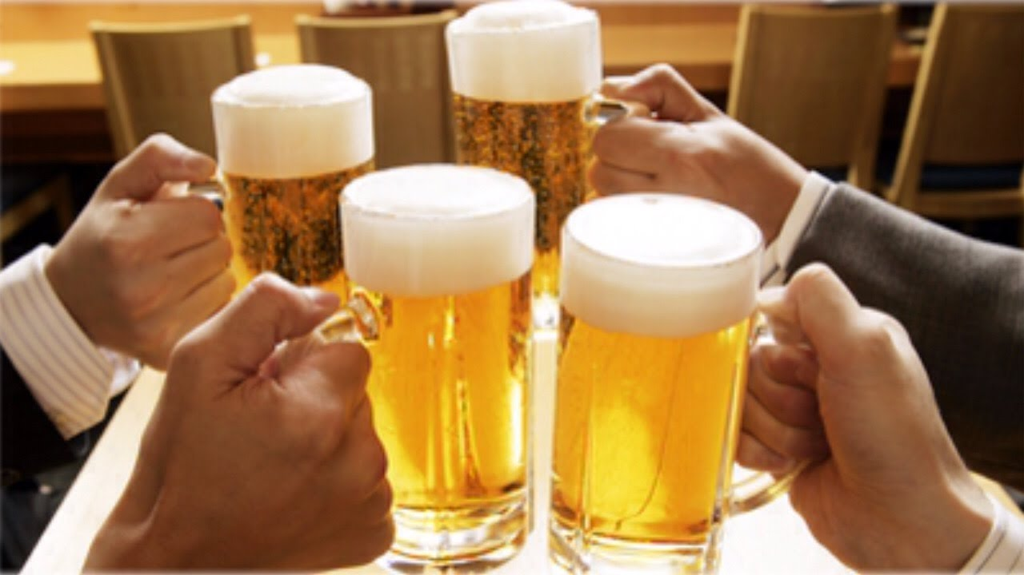
Thursday 6/9
^{(After work)}
Preston’s Patio
It’s time to get social again!
As always, everyone is welcome! Hope to see you there.