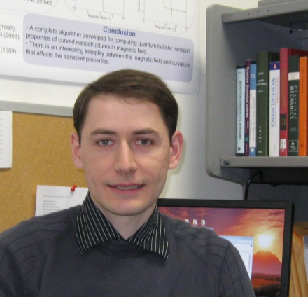

Bozidar Novakovic

Wednesday March 28, 2012

2:30pm to 4:00pm
Burton Morgan, Rm 121

“Quantum Transport In The Transient Regime and Unconventional Geometries”

Abstract - Modeling electronic devices in the transient regime is a topic of great interest in designing high switching and cut-off frequencies in digital and analog electronic circuits. A possible path toward achieving efficient high frequency operations (e.g. in the terahertz window) is increasing the frequency at which solid-state electronic devices can amplify and oscillate. In this talk, the theory and computational methods for modeling the transient regime in two-terminal ballistic nanostructures connected with dissipative macroscopic contacts will be presented. The question to be answered is how the current, as well as the potential and electron density, evolve in time in response to a sudden change in bias and how the time-evolution depends on the scattering time in the contacts and features of the self-consistent potential in the device region. The second part of the talk deals with nanostructures in non-planar geometries, whose fabrication gained some prominence today. The modeling of conductance and charge density in nanostructures in arbitrary geometry and magnetic fields will be covered in detail, including the use of the local Landau gauge. Examples of cylindrical and toroidal nanoribbons/nanomembranes with helicity will be shown.

Short Bio – Bozidar Novakovic is presently a dissertator in the Electrical and Computer Engineering Department at the University of Wisconsin-Madison. He is working towards his PhD degree under the supervision of Professor Irena Knezevic. Bozidar earned his B.S. degree in Electrical and Computer Engineering from the University of Novi Sad, Serbia, in 2005, his M.S. degree in Electrical Engineering from the University of Belgrade, Serbia, in 2007, and his M.A. degree in Physics from the University of Wisconsin-Madison in 2011. His current research interests cover all aspects of electronic transport theory and simulation.

