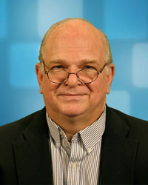
Michael Stroscio

University of Illinois at Chicago

Tuesday, March 27, 2012

2:00 pm to 3:30pm
BIRCK 1001

“Continuum Models of Phonons in Nanostructures”

Michael A. Stroscio, Richard and Loan Hill Professor and
Mitra Dutta, Distinguished Professor and Interim Vice Chancellor for Research

Abstract - This presentation will summarize the dielectric continuum model and its use in describing optical phonons and the elastic continuum model and its use in describing acoustic phonons. The talk will illustrate how to use these continuum models to describe few-phonon processes. In addition, the talk will discuss how to use these continuum results to model carrier-phonon interactions and to explain why confined phonon effects are especially important is selected classes of optoelectonic devices. The presentation will address the use of these continuum models in describing nanoscale structures.

Short Bio – PhD Physics, Yale University, 1974; MSc Physics, Yale University, 1972
- Fellow of the IEEE, 1992
- Fellow of the APS, 2004
- University Scholar, University of Illinois, 2004
- Fellow of AAAS, 1999
- 1998 IEEE-USA Harry Diamond Memorial Award, 1998
- Director of the Center for Integrated Networks of Nanoscale Sensors for Biomedical Applications
Research Interests - Professor Stroscio's research interests include: Electrical, optical, and mechanical properties of nanostructures, quantum transport, solid state electronics and optoelectronics, phonons in nanostructures, theory of nanodevices, applications of nanoscale structures and devices in electrical engineering and bioengineering.

