Keyence Microscopes Demo

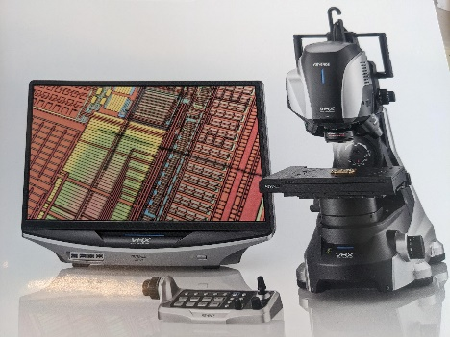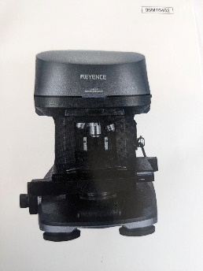

Find out the “Key” to getting fantastic images, measurents with the Keyence VHX-7000 digital microscope and in-depth meaurements on the Keyence VK-X3000. We have both of these microscopes in our cleanroom.
We will have two experts from Keyence here to demo the microscopes and answer any questions you might have. Representing Keyence and the VHX-7000 will be Devin Harrison. Representing Keyence and the VK-X3000 will be Austin Stachel.
Please feel free to ask questions, bring a sample you would like to have them look at or measure.
The session will be from 2pm-4pm tomorrow June 18, 2025. The location will be BRK 2001. Probably the VHX-7000 will be from 2pm to 3pm and the VK-X3000 will be 3pm to 4pm.Hope to see you there .
Bill Rowe 6/17/2025

