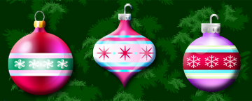

You are invited to the Birck
Cookie and Dessert Social
Bring your favorite cookies or dessert and we will celebrate
the Holiday Season
When: Tuesday December 21st
Where: Birck Atrium
Time: 2:00pm – 4:00pm

