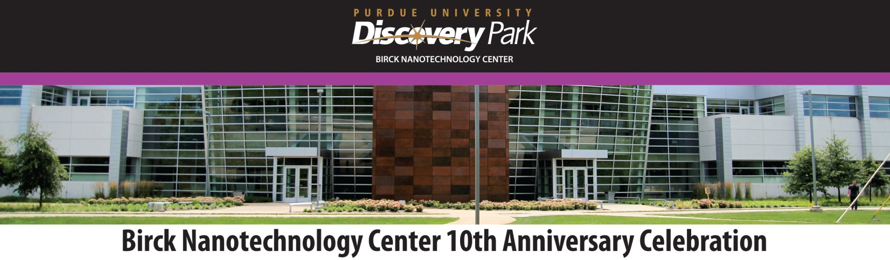
Friday, October 30, 2015
Room 121, Burton D. Morgan Entrepreneurship Center
8:00 – 8:15 am Introduction and Welcome: Deba Dutta, Provost
8:15 – 9:00 am Keynote Address: Progress Toward Wafer-Scale Thermionic Energy Conversion and Perspectives on Future University Shared Fabrication Facilities
Roger Howe, Stanford University
9:00 – 10:15 am Discovery Lecture Series: Panel on Nanotechnology Research beyond 2025
Timothy Sands, Virginia Tech; Roger Howe, Stanford University; Mark Lundstrom, Purdue University
10:15 – 10:45 am Break
10:45 – 11:45 am Nanotechnology at Purdue: BNC History and Prospects
Martin Jischke, Richard Schwartz, James Cooper, Rashid Bashir,
Timothy Sands, Ali Shakouri
11:45 – 12:00 noon Thanking Our Donors and Speakers
Café, Burton D. Morgan Entrepreneurship Center
12:00 – 1:00 pm Luncheon: Tribute to BNC Students
Room 121, Burton D. Morgan Entrepreneurship Center
1:00 – 1:10 pm NCN/nanoHUB: Overview by Gerhard Klimeck
1:10 – 2:30 pm Nanotech Madness
Fast-paced, exciting talks on technical topics in nanotechnology
2:30 – 3:00 pm Break
3:00 – 3:30 pm Commercialization and Nanotechnology
Atrium, Birck Nanotechnology Center
3:30 – 4:30 pm Reception: Tribute to BNC Staff
4:30 – 5:30 pm Poster Session in the BNC Atrium
Tours of the Birck Nanotechnology Center will be given from 9:00 am until 12:00 noon and from 1:30 pm until 3:30 pm

