Bindley Construction
Town Hall Meeting
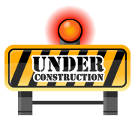
All Discovery Park personnel are invited to attend a Bindley Construction - Town Hall Meeting

Wednesday April 25th, 2012
2:30pm – 3:30pm
MRGN 121

Come learn about the impacts to all Discovery Park during the construction of the Bindley addition on the south side of the building. Information on parking, sidewalk access, building access, etc will be provided.

