COVID-19 Shared User Facility Standard Operating Procedure (SOP)

Instructions on how to prepare and submit the COVID-19 Shared User Facility SOP
This COVID-19 Shared User Facility SOP fillable template must be used for shared user facilities on the Purdue West Lafayette Campus. Multiple adjacent rooms or service spaces located in the same building can be included in a single SOP as long as the space has common oversight and supports a common research activity. Separate SOP fillable templates are available for Purdue’s individual and multi-investigator research spaces and field sites.
The COVID-19 Shared User Facility SOP should be completed for all centralized, professionally staffed shared user research facilities, including core laboratories, that provide access to instruments, technologies, services to approved internal and external researchers. At Purdue, centers, institutes, colleges, and departments provide oversight of shared user facilities. Over 100 of these facilities are recharge centers that are managed through iLab at Purdue.
Each COVID-19 Shared User Facility SOP should include a well-documented plan that everyone working in the space agrees to follow and enforce. The lab director/manager and other individuals responsible for oversight and operation of the facility should review the pre-read document and questions in the template before beginning. One person from this group should be designated as the Point of Contact (POC) to submit the SOP and manage subsequent communication.
This SOP should be used to describe how the layout of the shared user facility and the individuals using the space will comply with the Protect Purdue COVID-19 safety measures. This SOP should not be used to repeat or modify the Protect Purdue COVID-19 safety measures and processes, such the health and wellness protocols and the required use of cloth or disposable face masks, which are available on the Protect Purdue Website.
Please send a message to COVIDSOP@purdue.edu for assistance in determining the correct SOP template for a research space and/or completing the SOP template. Use the subject line Shared User Facility SOP Assistance.
Before returning to campus, all members of the shared user facility team who either conduct or support the research activities covered by this plan must: (1) review the pre-read for background and awareness; (2) complete online COVID-19 Protect Purdue training; (3) read and understand the attached SOP; (4) participate in a group meeting to discuss the SOP; (5) sign the SOP indicating understanding of Shared User Facility SOP and intent to follow SOP.

Using the COVID-19 Shared User Facility SOP fillable form
The COVID-19 Shared User Facility SOP is using a MS Word fillable form to collect information in a standard format for rapid review and feedback. Input can be added to the field by clicking on the field and typing the response. Additional fields can be added by clicking on the “+” found at the lower right-hand edge of the first field.

COVID-19 SHARED USER FACILITY SOP

Shared User Facility and Point of Contact for SOP Submission
This section collects information on the shared user facility rooms and service areas that will be covered by the SOP and the contact information of the POC for the SOP submission. All communication on the review and approval process will be routed through the SOP submitter. Click on “+” at the lower right-hand corner of the fillable field to add additional fields.

Building Code: WSLR
Shared User Facility Name: Purdue Electron Microscopy Facility
Room Number(s): BRK 2100N, 1269, 1237, 1235, 1233 WSLR S042-S062
Unit Responsible for Oversight of the Facility: ARGE Shared User Facility SOP Submitter Information:
Name: Gilpin, Christopher E-mail: gilpin@purdue.edu Select College: Agriculture Department: ARGE
Institute/Center: Enter institute/center
Position Title: Director Life Science Microscopy Facility Research in this Shared User Facility Includes (check all that apply):
☒ COVID-19 Research
☒ Animal Research
☒ Human Subject Research
- Leverages Field Research, State, National, or International
Note: Purdue placed additional restrictions on animal, human subject, and field research in March. This SOP does not serve as an approval process to resume activities that are still subject to current restrictions found at this link Guidance for Human Subjects Research.

Other Shared User Facility Personnel Included on the SOP
Purdue’s shared user facilities are centralized, professionally staffed research labs, including core laboratories, that provide access to instruments, technologies, services to approved internal and external researchers. At Purdue, centers, institutes, colleges, and departments provide oversight of shared user facilities. Many are recharge centers that are managed through iLab at Purdue.
Q1: Complete the following question if the shared user facility is staffed by personnel other that the SOP submitter. Include information on all personnel associated with the shared user facility, including personnel who manage lab administration and operation, conduct experiments for users, work with users, train users, calibrate and maintain equipment, etc. Only complete the parts that are applicable. NOTE: This question is NOT requesting information on the shared facility users.

To add personnel, hover cursor over large gray box and click to show “+” at the lower right-hand corner of the entire field.
Any individual at high-risk for severe illness or complications from COVID-19 should directly contact Purdue HR for a consultation before returning to campus work. Work that doesn’t require access to the shared research facility should be done remotely whenever possible.
Shared User Facility Personnel Information:

Existing Emergency Contact? ☐ Yes ☒ No Name: Mueller, Laurie
E-mail: muell16@purdue.edu Select College: Agriculture Department: ARGE
Institute/Center: Enter institute/center Position Title: Research Assistant
Approximate % time on campus needed to perform work: >75%

Existing Emergency Contact? ☐ Yes ☒ No Name: Seiler, Robert
E-mail: seilerr@purdue.edu Select College: Agriculture Department: ARGE
Institute/Center: Click or tap here to enter text. Position Title: Research Assistant
Approximate % time on campus needed to perform work: >75%

Existing Emergency Contact? ☐ Yes ☒ No Name: Shoumya Nandy Shuvo
E-mail: sshuvo@purdue.edu Select College: Engineering Department: MSE
Institute/Center: Click or tap here to enter text. Position Title: graduate student RA
Approximate % time on campus needed to perform work: 50-75%

Existing Emergency Contact? ☐ Yes ☒ No Name: Diaz, Rosa
E-mail: rdiazri@purdue.edu Select College: Engineering
Department: Birck Nanotechnology Center

Institute/Center: Birck
Position Title: Staff Scientist  Approximate % time on campus needed to perform work: | 25-50%
Existing Emergency Contact? ☐ Yes ☒ No
Name: Eberle, Jan
E-mail: jgeberle@purdue.edu
Select College: Agriculture
Department: Click or tap here to enter text.
Institute/Center: EVPRP
Position Title: Electron Microscope Specialist Approximate % time on campus needed to perform work: | >75%
Existing Emergency Contact? ☐ Yes ☒ No
Name: Liu, Xingtao
E-mail: liu1749@purdue.edu
Select College: Engineering
Department: Industrial Engineering
Institute/Center: Click or tap here to enter text.
Position Title: graduate student research assistant Approximate % time on campus needed to perform work: | 25-50%
Existing Emergency Contact? ☐ Yes ☒ No
Name: Alam, Talukder
E-mail: alam18@purdue.edu
Select College: Engineering
Department: MSE
Institute/Center: Click or tap here to enter text.
Position Title: Research engineer  Approximate % time on campus needed to perform work: | 50-75%

Other Researchers Included on the SOP
Shared user facilities are open to internal and external users who are trained on one or more of the instruments in the facility and are approved to use the lab. To maintain social distancing guidelines and de-densify our spaces, it is critical that all individuals requiring access to on-campus facilities, including shared user facilities, understand and follow the Purdue COVID-19 safety measures. This will include limiting time spent on-campus to tasks that rely on specialized on-campus facilities.
All other work should be conducted remotely whenever possible. It may also require scheduling on- campus activities in multiple shifts across the day.

Q2: Confirm that the shared user facility director, manager, or designated individual will ensure that all internal and external users will complete the following before returning to the lab: (1) review the pre-read materials; (2) complete the COVID-19 online training; (3) review COVID-19 risk matrix and take appropriate actions if at high-risk; (4) review and understand the Shared User Facility SOP and any equipment specific safety measures; (5) have the opportunity to discuss the SOP with responsible shared user facility personnel. ☒ Yes ☐ No

Practices to Comply with COVID-19 Safety Measures in Shared User Facilities
Shared user facilities at Purdue (except those with active COVID-19 programs) are currently considered medium exposure risk by Occupational Safety and Health Administration (OSHA). All individuals returning to campus to conduct or support research activities, or those currently conducting critical research, will be held accountable for understanding and implementing the COVID-19 Shared User Facility SOP. The SOP must clearly describe how the spaces, processes, and practices of all rooms and individuals covered by the SOP will be adapted to comply with the current COVID-19 research safety measures below:
- Conduct research activities remotely whenever possible;
- Do not come to campus when experiencing COVID-19 symptoms or after close, prolonged contact with a confirmed COVID-19 carrier. See Protect Purdue Pledge;
- Pay attention to personal hygiene, including frequent hand washing with soap and water;
- Wear cloth or disposable face mask when a 6 ft distance between individuals cannot be maintained at all times;
- Maintain a 6 ft. separation between people working in all shared research spaces for social distancing and de-densification;
- Incorporate engineering controls such as physical barriers and/or enhanced PPE when unable to maintain a 6 ft. separation between people working in a research space;
- Clean and sanitize shared surfaces and equipment frequently, using COVID-19 approved
cleaning products and procedures;
- Maximize separation between people when moving through research spaces;
The shared user facility director, manager and/or other responsible personnel should consider how to apply a combination of best practices across the four primary control areas for the lab and shared equipment: Physical Distancing, Social Distancing, Contact Time, Reducing Exposure.
PHYSICAL DISTANCING encourages remote work and video communication whenever possible. It also includes limiting trips to essential research travel to field sites, sponsor reviews, national user facilities, collaborator facilities.
SOCIAL DISTANCING is used to maintain the equivalent of a 6 ft. separation between people working in research spaces. Methods include installing floor markings to manage circulation and identify separation when waiting for shared equipment; removing or labeling desks, tables, and chairs; rearranging furniture and equipment to increase distance between high-use items; shutting

down or staggering work in benches, hoods, or other stationary equipment; adding engineered controls such as Plexiglas barriers between adjacent work areas or enhanced PPE.
CONTACT TIME should be minimized by de-densifying and adopting approaches such as staggered work shifts, avoiding peak travel times, and using reservation systems for shared labs.
REDUCING EXPOSURE is aimed at minimizing cross-contamination. Approaches include assigning work areas to particular researchers; frequent hand washing and use of hand sanitizer; regular cleaning and disinfection of surfaces and shared equipment; reassigning research responsibilities to limit the number of different researchers in a shared space; limiting external visitors to essential contractors and vendors. Most importantly, individuals should not come to campus when experiencing COVID-19 symptoms or after close, prolonged contact with a confirmed COVID-19 carrier.
Note: Individuals at high risk for severe illness or complications of COVID-19 may require additional accommodations and protective safety measures to return to campus. Anyone who may be medically vulnerable to serious illness or complications from COVID-19 should complete the assessment process to protect those most vulnerable and take appropriate action.
The following questions will assist in developing and implementing COVID-19 safety measures, practices and processes for the research spaces covered by this SOP.

Q3: What are the room type(s) for this shared user facility? (check all that apply):
☒ Office space shared by four or fewer individuals
  - Open office shared by five or more individuals
☒ Open dry space with benches, tables, and/or desks
☒ Dry bench
☒ Wet bench
☒ Analytical testing
  - Physical testing
☒ Sample storage
☒ Other: Microscope rooms, equipment rooms

Q4: Briefly describe the activities that will be performed in the shared user facility covered by this SOP.

Most of the rooms are occupied by a single electron microscope which will be used for imaging and analysis. There are also rooms for sample preparation for electron microscopy.

Q5: Provide examples of the type of work that can be done remotely to support shared user facility personnel and users.

Billing and procurement. Although note that not all staff have computers or internet at home. Remote control of microscopes to both use and to provide help and support and possible training.

Q6: Confirm that the shared user facility personnel and users will communicate via video conference when possible. ☒ Yes ☐ No

If no, explain how social distancing will be maintained.

Q7: Confirm that all responsible individuals who serve as supervisors understand that anyone who may be medically vulnerable to serious illness or complications from COVID-19 should complete the assessment process to protect those most vulnerable. A Purdue HR representative will work with the individual and his/her supervisor to identify appropriate workplace accommodations. The supervisor cannot require the individual to return to campus until this process is complete. Individuals not at high-risk can return to campus after the COVID-19 Shared User Facility SOP is approved and training is complete. ☒ Yes ☐ No

Q8: Confirm that everyone covered under this SOP understands that no individual should come to campus when experiencing COVID-19 symptoms or after being in close, prolonged contact with a confirmed COVID-19 carrier. Supervisors should support and enable these individuals to remain at home during this time. ☒ Yes ☐ No

Q9: Confirm that everyone covered by this SOP will follow requirements for wearing a cloth or disposable face mask. ☒ Yes ☐ No

Q10: Confirm that the shared user facility covered by this SOP has a sink suitable for hand washing or will have hand sanitizer available. ☒ Yes ☐ No

Q11: Confirm that everyone covered under this SOP understands that all Integrated Safety Plans requirements for appropriate laboratory practices and PPE remain in place, including in-person or remote buddy systems. ☒ Yes ☐ No

Q12: Insert a simple hand-drawn or electronic sketch of the shared user facility space covered by this SOP in the blue box, including critical dimensions where possible. Show the approximate location of major equipment, racks, benches, tables, desks, chairs, etc. For multiple sketches, hover cursor over large gray box and click to show “+” at the lower right-hand corner of the entire field.
Floor plans can be accessed on this page with a valid Purdue login.

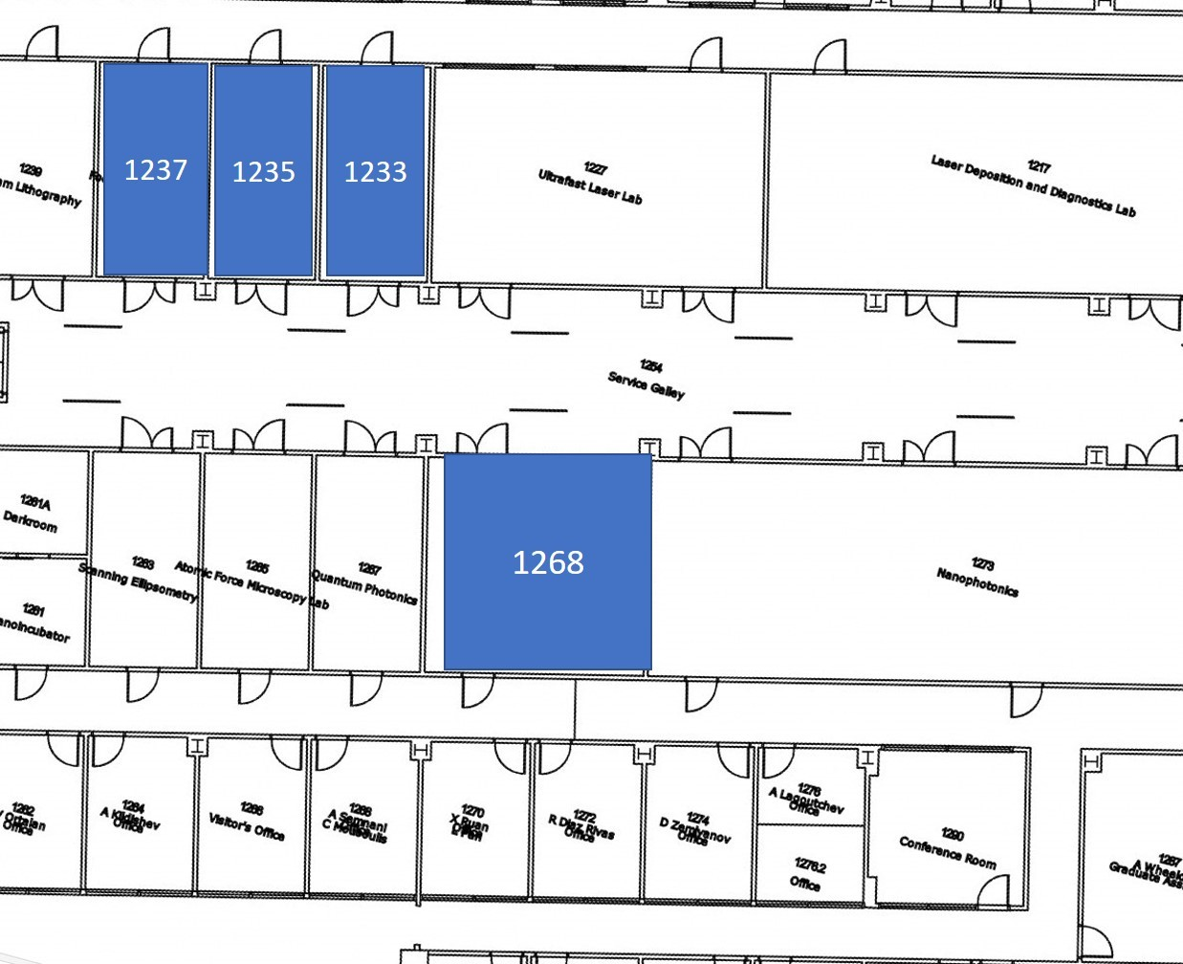

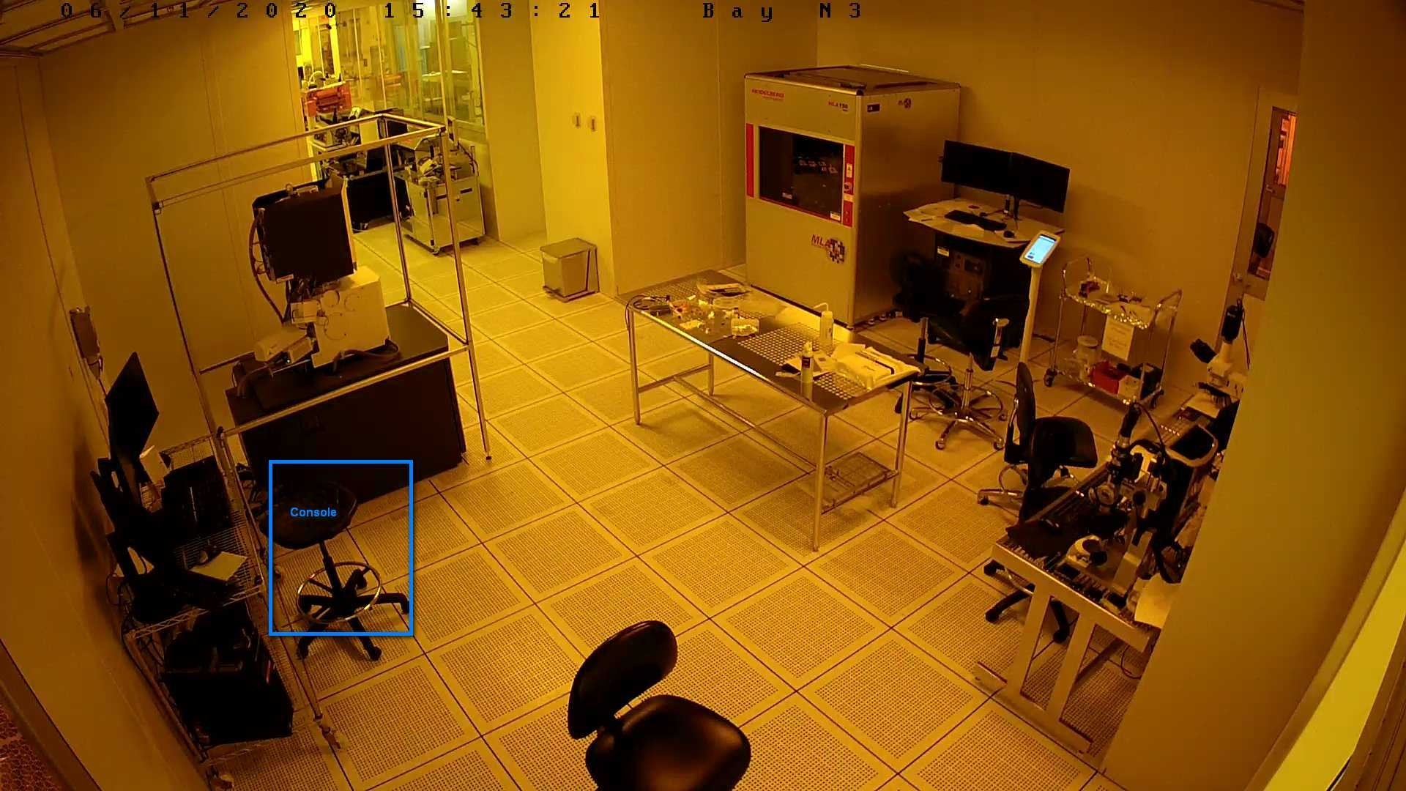
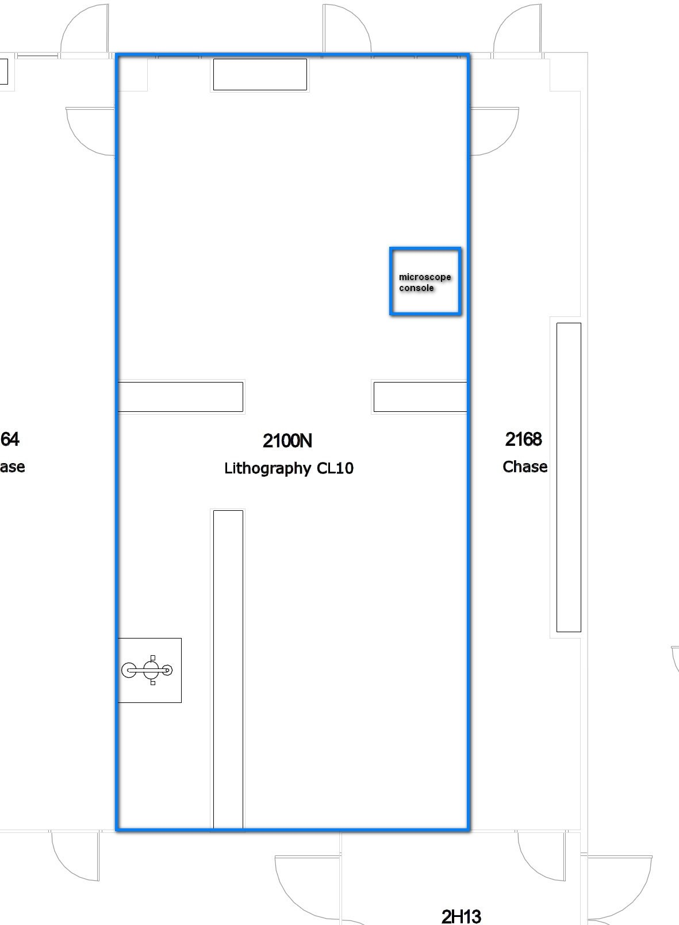

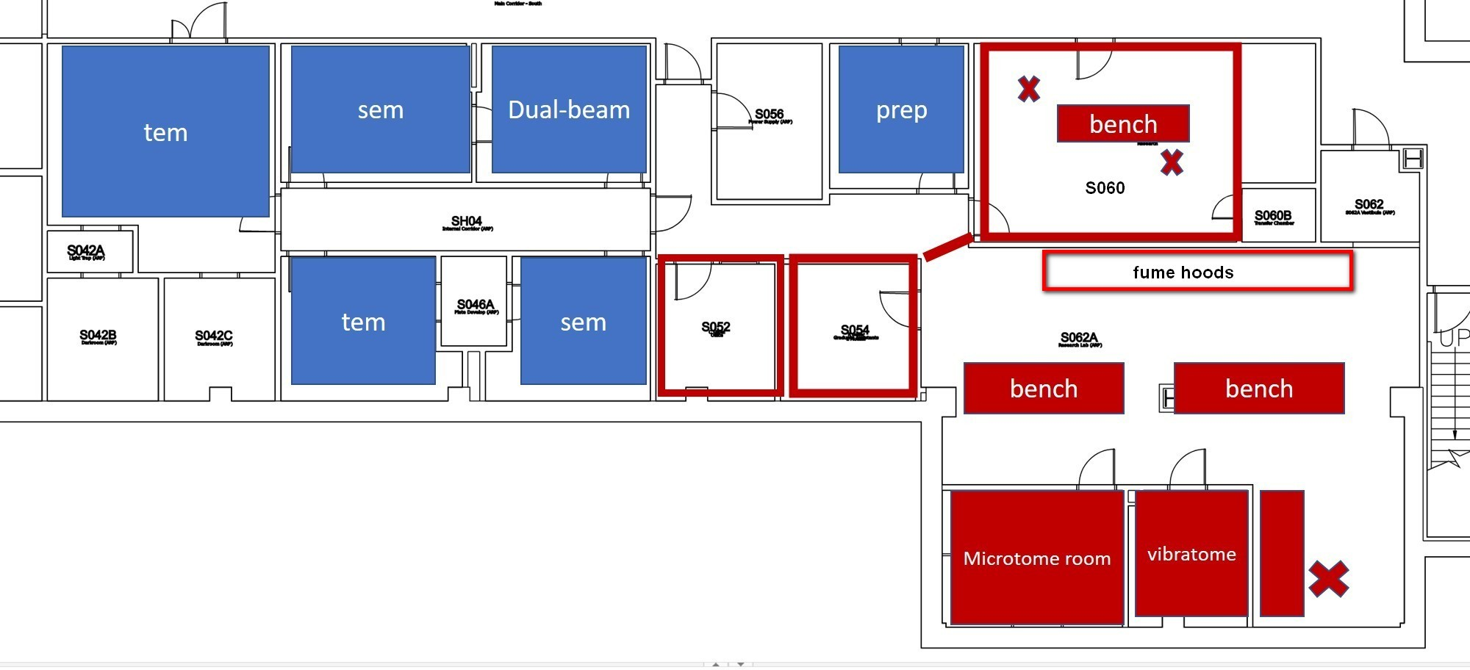
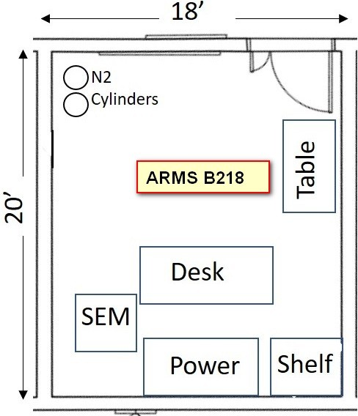

Q13: Does the shared user facility covered by this SOP plan to use a staggered work shift to maintain the required social distancing? ☐ Yes ☒ No

Q13a: If yes, confirm that a shared online tool or other method is available to track staggered work shifts. ☐ Yes ☐ No

Q13b: Confirm that a shared online tool or other method is available to schedule use of shared equipment. ☒ Yes ☐ No

Q14: Based on the rough sketch of the shared user facility, provide a brief description of the approaches that will be implemented to maintain the required social distancing by annotating the sketch and/or providing a short narrative below. This could include: floor markings to manage circulation and identify separation when waiting for shared equipment; removing or labeling desks, tables, and chairs; rearranging furniture and equipment to increase distance between high-use items; shutting down or staggering work in benches, hoods, or other stationary equipment.

The covid-19 and human and animal research boxes were checked because samples that go in the electron microscopes can come from those categories. But to the microscope users and staff they are prepared specimens not live, or infectious!

For Birck 1269, 1237, 1235, and 1233 access is swipe card controlled for each room. Each room will have one person at a time. iLab calendars will be used to reserve time for the instrument in each room. 1233 is a prep room with several piece of equipment – each will be linked in iLab to ensure that only one can be used at a time.

For Birck 2100N. This is a scanning electron microscope housed in a clean room bay. Clean room access is controlled, and every user will be wearing a full suit and gloves. No skin contact is allowed in the clean room. Microscope time will be controlled with an iLab calendar meaning only one person can use it at a time. The photograph shows the back bay layout in detail. Note each floor tile is 24”x24”. The other two pieces of equipment in the back bay are more than 6ft from the microscope and its console.

For Whistler S042-So62 The blue squares are either TEM rooms, SEM/dual-beam rooms or a prep room. For the microscopes there is only one instrument per room and each has an iLab calendar to restrict to single person use. The prep room will have two pieces of equipment but these will have their iLab calendars linked so that only one can be used at a time.

Rooms with Red outline are staff only rooms. There is a red tape line on the floor delineating the entrance to staff only space. S052 and S054 will be arranged to be a single person office. S060a will be reconfigured to have two workstations separated by 15ft and on the opposite side of a bench.
Marked on the drawing by red crosses.

S062a will have one workstation marked by the red cross. The fume hoods will only be used by staff. There are two staff who will use the fume hoods and they will be responsible for arranging when they will be in use to have only one person at a time.

The microtome room and vibratome room are staff only and will have only one person at a time. There are only two staff who will use these rooms and they will be responsible for arranging when that room will be is use.

The other rooms in the drawing – S042A, S042B, S042C, S046a, S056, S060B, S062 are utility rooms housing pumps, water chillers etc. These will be accessed infrequently and by only one person at a time.

Access to the facility from the hallway is card swipe controlled. Only trained user will be allowed to enter until training is resumed at a later date.

ARMS B218. One person in the room at a time. Controlled by reservation system in iLab. Further building controls will be implemented by MSE department.

If users require assistance on any equipment then one of two scenarios will occur. If possible instruments will be accessed remotely to provide assistance. If this is not possible the user will be asked to leave the room while a staff member attends to the problem. There is at least 6ft from each doorway to the console seat so it is possible to provide verbal assistance from a safe distance

Q15: Based on the rough sketch of the shared user facility and its anticipated use, are there activities or instances when social distancing cannot be maintained for a prolonged period of time and Plexiglas needs to be installed or enhanced PPE will be required? ☐ Yes ☒ No

If yes, provide short description of the activities for which Plexiglas or enhanced PPE is needed (including frequency/duration of contact and distance between individuals).
Include Plexiglas on sketch or describe where Plexiglas should be installed.

Q15a: If Plexiglas needs to be installed, confirm a work order has been placed with Physical Facilities to install the Plexiglas via the Fix-it Portal. When placing the order please specifically mention this is a research-related request. ☐ Yes ☐ No

Q15b: If yes for Q14a, while waiting for physical facilities to install Plexiglas, describe the interim safety measures that will be used.

If yes for 16a, provide short description of interim safety measures.

Q16: Confirm that everyone covered by this SOP, including shared user facility users, agree to clean and disinfect frequently touched surfaces and equipment used by more than one individual using a CDC approved disinfectant that is appropriate for the surface or equipment. For example, wipes or sprays containing at least 70% alcohol or ethanol are a good choice for disinfecting keyboards, microscopes, and other sensitive equipment. ☒ Yes ☐ No

Q17: Describe any additional COVID-19 safety measures that will be implemented to reduce contact time, reduce exposure, or any other controls.

We plan on creating a new permission group in iLab that will require staff approval to use instruments. Approval will be given after the user has signed to agree to the SOP procedures. The user will then be pout in a group that can freely make reservations. We will ask and then verify that user leave a minimum of 15 minutes between reservation slots to allow for cleaning. During the cleaning time iLab interlock control will be used to ensure that users are not billed for the cleaning time.

Q18: Confirm that shared user facility personnel covered under this SOP will participate in a meeting with the POC and supervisor to discuss this SOP. ☒ Yes ☐ No

Q19: Confirm that signatures will be collected from those who need access to the shared user facility confirming awareness and agreement to follow SOPs outlined in this document prior to accessing the facility. ☒ Yes ☐ No

COVID-19 Shared User Facility SOP Signature Page
By signing below, all personnel associated with this shared user facility acknowledge that they endorse the plan in the attached COVID-19 Shared User Facility SOP and agree that it should be submitted for review and approval.
Once the SOP has been approved, the facility director, manager, or designated responsible individual will ensure that all other internal and external users requiring access to the facility have completed all the requirements to return to the lab. The shared user facility is responsible for gathering signatures and maintaining up-to-date records that will be kept in the lab.
Privileges to this and other research spaces on the Purdue campus will be revoked if the signees do not follow the measures in this SOP.
Click “+” for additional fields. Insert name here
Christopher Gilpin | 6/15/2020 | gilpin@purdue.edu
Signature | Date | E-mail or phone #

Insert name Rheoresa E Diaz 06/13/20 rdiazri@purdue.edu
Signature Date E-mail or phone #

Insert name here
06/15/2020 sshuvo@purdue.edu

Insert name here

Insert name here
Signature Date E-mail or phone #

Laurie Mueller 6/15/2020 muelle16@purdue.edu

Signature Date E-mail or phone #

Robert Seiler 6/15/2020 seilerr@purdue.edu
Signature Date E-mail or phone #

Jan Eberle 6/15/2020 jgeberle@purdue.edu

Xingtao Liu 6/15/2020 liu1749@purdue.edu Talukder Alam 06/17/2020 alam18@purdue.edu

Electron Microscopy Facility Instructions

- Materials:
  - Safety glasses or googles (Birck)
  - Facial masks covering nose and mouth
  - Gloves
  - Disinfectant – hydrogen peroxide 3% or alcohol 70%

- PPE – Personal responsibility
  - Following social distance protocols, ONLY one trained user per lab or room or microscope room is allowed in the EM core facilities. For the Apreo S area in the clean room please keep the 6 feet distance rule at all times.
  - Face masks need to be worn at all times in public spaces but if you are alone in a room it is ok to remove a mask. Wear a mask under cleanroom veils when using the Apreo S. In other than the cleanroom you will be expected to provide your own mask.
  - Gloves are required when mounting samples on sample holders, as well as when inserting sample holder in SEM chambers or TEM column. When using sample preparation rooms wear gloves. It is not feasible to clean things like scissors and rolls of carbon tape. If you prepare samples directly in the microscope room wear gloves and we are encouraging users to keep wearing those gloves throughout their session. Avoid touching your face and mask while wearing gloves. Discard gloves every time you exit room.

- OPERATION
  - BEFORE using any equipment, please disinfect all surfaces that you will use or touch, i.e., keyboards, mouse, panels, loading chamber rod, sample holders, display power buttons, chairs, counters, LN2 dewar handles, etc., USING hydrogen peroxide 3% or alcohol 70% located in each of the rooms.
  - Keyboards, mouse, and hand panels are NOT waterproof, so DO NOT directly spray those with disinfectant, please wet a wipe first and then wipe down such surfaces.
  - Users should be mindful of where his/her hands will touch and clean accordingly.
  - The EM core will give special permissions in iLab to reserve the requested microscope to those users who are already trained and who have signed the SOP.
  - Please leave a 15 minute gap between reservations. This is to give time for cleaning. You may clean before logging in to the iLab session.
  - If there is no other user after you then it is ok to extend your session using the iLab kiosk function. Do NOT just keep using the equipment until the next user shows up. By extending the session in the kiosk this will be added to the calendar so that other users will be able to maintain that 15 minute gap.
  - Do not use the walk up function for reserving equipment. Reserve in advance.
  - To help maintain distancing please reserve all preparation equipment in iLab.
e.g. sputter coater, glow discharge, pips etc. Where there are multiple pieces of

equipment in a room we will link them in iLAb so that only one can be reserved at any one time.
  - In Whistler there is a red tape line on the floor by the entrance to S060 and the staff office. Only staff should cross this line.
  - For staff assistance. This is complex and will evolve. Initially we can try and provide remote access. If that is not possible use the normal channels for reaching staff. In Whistler this may involve creating a noise at the red tape line. Bang the metal pitcher!
  - In Whistler we have provided paper towels to use to open doors. Please use these even if you have gloves on. Do not rely on door handles being clean!

All users will be expected to sign this document before being able to use microscopes. Please sign and return the SOP using a filename that is lastname_first name_microscope name1_microscope name2_etc

So e.g gilpin_christopher_nova_hitachi_apreo

Different buildings will have different card access requirements above those used by the EM facilities. Please contact Chris Gilpin for Whistler, Rosa Diaz or Xingtao Liu for Birck or Talukder Alam for Armstrong. For some there will be building access required as well as either facility or individual room access.

COVID-19 SOP Signature Page
By signing below, users acknowledge that they have read and will follow all details of the attached COVID-19 SOP and instructions.

Name Signature Date email

