Announcing a new graduate level course, fall 2024, for those students interested in helping shape the future of healthcare:
BME 69500: Digital Health Transformation
Healthcare is in the early stages of the most transformative periods in modern times. This is being driven by not only the recent availability of a wide range of digital health technologies, but also the critical shortcomings within current systems of care including widespread disparities, poor patient outcomes, provider burnout, and unsustainable costs.
This new class is designed to give students (limited to a maximum of 20) the opportunity to dive deeply into medical care and how novel digital technologies are currently, and will even more so in the future, disrupt healthcare. Students will be expected to actively participate in the analysis and discussion of the latest evidence through weekly journal clubs. In addition, each week there will be virtual or in-person discussions with some of the leading disruptors in the field – founders, and transformative leaders within life science and health care organizations.
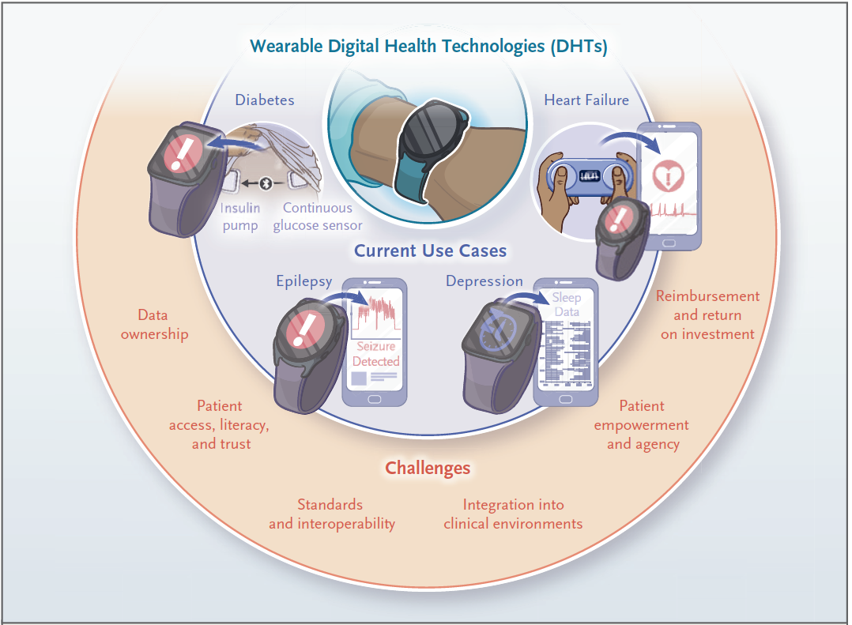
Beyond in-class activities, students will also be directly exposed to healthcare through shadowing local health care providers (Family Health Clinics) who are caring for individuals in rural areas surrounding Purdue. Following two shadowing experiences, and in-class discussions, student teams (2-4 members depending on class size) will identify a problem to be solved for providers and/or patients in that setting and develop a potential solution. As a final project, each team will create a detailed proposal of how they would plan to implement and test their recommended solution.
Additional information:
- 3 Credits
- Instructor: Steve Steinhubl, MD
- In person only - MJIS 1083.
- MWF 1:30 – 2:20 PM
Figure from Ginsburg, Geoffrey S., Rosalind W. Picard, and Stephen H. Friend. "Key issues as wearable digital health technologies enter clinical care." New England Journal of Medicine 390.12 (2024): 1118-1127. DOI:10.1056/NEJMra2307160
- Transportation to clinics will be needed (can be coordinated with other students).
- For more details, email ssteinhu@purdue.edu

