Research Fellowship
Center for Vascular Research (CVR)
University of Maryland & Baltimore VA
www.TheCVR.org
www.TheVIC.org

Brajesh K. Lal, MD
Director, CVR
Professor of Vascular Surgery, University of Maryland
Professor of Neurology, Mayo Clinic
blal@som.umaryland.edu

Sarasi Desikan, MD, FACS
Director, CVR Research Fellowship
Assistant Professor of Vascular Surgery
sdesikan@som.umaryland.edu

John Sorkin, MD, PhD
Director, CVR Biostatistics and Informatics Core
Professor of Medicine
jsorkin@som.umaryland.edu

TABLE OF CONTENTS

Introduction to the CVR
Mission ……………………………………………………………………………………………………………………………………….3
Objectives …………………………………………………………………………………………………………………………………..3
Team ………………………………………………………………………………………………………………………………………….3
Funding ……………………………………………………………………………………………………………………………………….3

Projects at the CVR………………………………………………………………………………………………………………………………….4

The CVR Research Fellowship
Purpose …………………………………………………………………………………………………………………….………….…...5
Research objectives.………………………………………………………………………………………………………..…….……5
Mentorship objectives ………………………………………………………………………………………………………….…….5
Clinical objectives...……………………………………………………………………………………………………………...…….5
Expectations for the fellow…………….……………………………………………………………………………………….…..6
Resources for the fellow………………………………………………………………………………………………………………6
Publications from our fellows………………………………………………………………………………………………………7

Application requirements………………………………………………………………………………………………………………………..8

INTRODUCTION TO THE CENTER FOR VASCULAR RESEARCH

Mission
To improve vascular health through innovation, creativity, and discovery.

□ The CVR Director's Message

Objectives
The Center for Vascular Research (CVR) is dedicated to high quality clinical and translational research by engaging in:
1. Basic discoveries of the causes for vascular disease
2. Translation of basic discoveries into preventive, diagnostic, and treatment protocols
3. Testing of new protocols and devices for safety, efficacy, and comparative effectiveness
4. Training and mentoring of emerging physicians and scientists

Team
The Center encompasses resources located at the University of Maryland School of Medicine (UMSOM), University of Maryland Medical Center (UMMC), Baltimore VA Medical Center (BVAMC), University of Miami (UM), and George Mason University (GMU). Members include highly qualified multi-disciplinary health care professionals including physicians, career scientists, mid-level providers, registered nurses, research coordinators, regulatory specialists, fellows, residents, and students.

The Center brings together a diverse range of expertise including Vascular and Endovascular Surgery, Vascular Medicine, Vascular Biology, Neuroradiology, Geriatrics, Neurology, Neuropsychology, Physical Medicine and Rehabilitation, Exercise Physiology, Bioengineering, Computer Science, Epidemiology, and Biostatistics. This multispecialty team provides the full range of knowledge and experience needed to address and advance research in vascular diseases.

□ The CVR Faculty and Staff

Funding
The Center has been continuously supported for the past 10 years through federal, industry, foundation, and private resources.

PROJECTS AT THE CVR

We are a dedicated research team committed to ensuring high quality standards and data integrity, while providing the utmost respect and exceptional care to our patients participating in over 40 active research protocols in the Center. The exposure to diverse vascular pathologies, the multidisciplinary team, and the resources at the CVR allows research fellows to experience cutting edge research first-hand. We have ongoing research in almost all vascular territories within the body (see figure).

□ Ongoing projects at the CVR

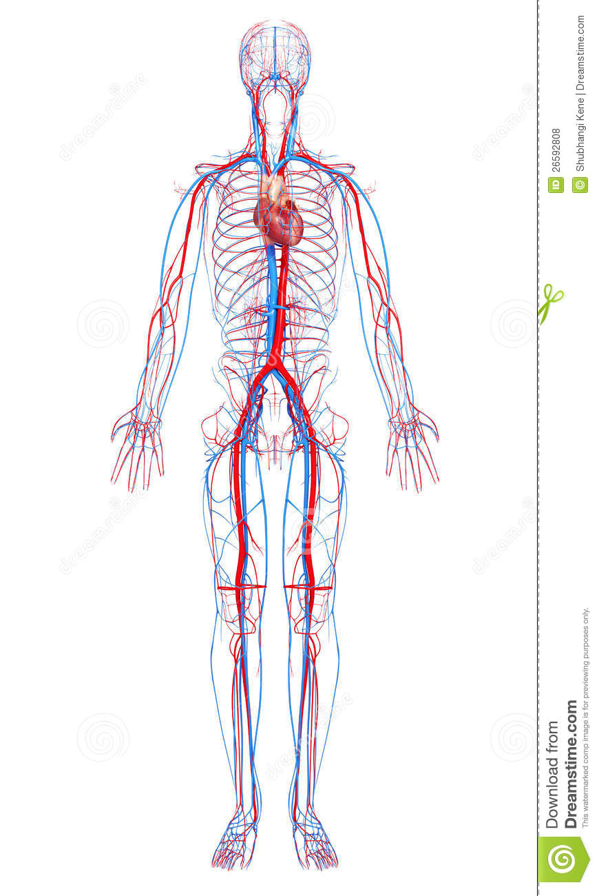
Carotid arteries
-Stroke
-Cognitive dysfunction
- Mobility/balance
Dysfunction
-Plaque morphology
Aorta
-Aneurysm
-Dissection
Lower extremity
Arteries
-Claudication
-Gangrene
- Amputation
Lower extremity veins
-DVT
-PTS
Pulmonary arteries/veins
-Pulmonary embolism
-Post PE Syndrome
Renal arteries
- Renal failure
- Hypertension
Mesenteric arteries
-Bowel ischemia

THE CVR RESEARCH FELLOWSHIP
Purpose
Our goal is to create a holistic experience for our research fellows that focuses on developing a strong foundation in clinical research, along with one-on-one mentorship, and opportunities to gain clinical experience. Each research fellowship is tailored to fit the applicant’s needs, interests, and goals. Here, we provide an overview of the goals and expectations for fellows spending dedicated time at the CVR.

The fellowship is open for
- Undergraduate students taking a gap year (or more) during or after their training
- Medical, Osteopathic, or Graduate students taking a gap year (or more) during or after their training
- Residents in any specialty taking a gap year (or more) during or after their training

Research objectives:
Prior to beginning their research fellowship, fellows at the CVR will be assigned a primary faculty mentor. Through the mentor, they will be introduced to the various avenues of research being performed at the Center. The fellow will select, develop, and focus on a primary project during the fellowship that aligns with their interests and career goals. Through the primary project, they will gain experience with:
- Development of a scientific question
- Performing a review of literature
- Study design
- Regulatory processes involved with research
- Obtaining patient consent
- Testing and data collection
- Data analysis
- How to develop a research talk and present findings
- Abstract and manuscript development

Mentorship objectives:
Accepted fellows will be matched with a primary mentor based on their line of research and career goals. This primary mentor will not only oversee the progress of the fellow’s research efforts but will also develop a mentorship plan to help the fellow progress in their career goals. With this mentorship program, fellows will:
- Develop short- and long-term goals for their research and career
- Collaborate with their mentor to develop a plan to progress towards these goals over the time spent at the CVR
- Learn to put together an effective CV
- Critically review and improve upon medical school, residency, fellowship, or other applications (if applicable)
- Practice interviewing skills (if applicable)

Clinical objectives:
Although the focus of this fellowship is to provide a strong research experience, the world class clinical care provided by the Vascular Division spanning the University of Maryland and the Baltimore VA, provides a phenomenal opportunity for fellows to gain experience in the clinical setting as well. During their time at the CVR, fellows will be provided with the opportunity to expand their clinical knowledge and experience through a combination of the following:
- Interaction with patients involved in clinical trials at the CVR
- Shadowing experiences in the clinic and operating room settings, particularly those relevant to their research question
- Participation in clinical rounds and conferences

Expectations from the Fellow:
Our goal is to provide a productive and enjoyable experience for CVR fellows. This experience is optimized by fellows being proactive and putting in the required effort to make their projects a success.

- Prior training or experience in research is not a pre-requisite.
- Project development. Fellows are expected to work with their mentor to develop their primary project and ensure that it progresses.
- Reading. Fellows will be provided an extensive reading list, and in addition, will be expected to learn how to conduct literature searches using online tools (PubMed, Medline, and others).
- Citations. Fellows will be provided instructions and should create a Mendeley account to maintain citations.
- Respect. Fellows should be respectful to study team members and patients at all times.
- Punctuality. We expect fellows to be punctual and reliable. This is a key component of successful clinical research. Days off should be discussed and confirmed with the fellow’s Mentor and the Clinical Research Manager. Fellows should let the research team know as soon as feasible for any unexpected absences.
- Research training and credentialing. Fellows should complete the required credentialing paperwork and training in Human Subjects Research through resources provided by the CVR.

Resources for the Fellow:
The goal of this experience is for fellows to develop a well-rounded understanding of all aspects of clinical research from inception to the dissemination of findings. To facilitate their experience, the fellows will receive access to:

- Office and desk space
- Desktop and laptop computers as appropriate for their projects
- Data management, statistical analysis, and research software
- Dedicated space on the CVR research server
- Remote access privileges to their accounts/computers
- Access to all University and VA intranet resources including the library, clinical and research information
- A stipend based on the fellow’s need and availability of appropriate funding within the CVR.

Publications from our research fellows:
Our research fellows have published over 100 manuscripts over the past 5 years alone. Publications from our fellows in 2022 include:
- Englum BR, Prasad NK, Lake RE, Mayorga-Carlin M, Turner DJ, Siddiqui T, Sorkin JD, Lal BK. Impact of COVID-19 Pandemic on diagnosis of new cancers; A national multicenter study of the Veterans Affairs Healthcare System. Cancer, 2022; (5)1048-1056
- Prasad NK, Lake R, Englum BR, Turner DJ, Siddiqui T, Mayorga-Carlin M, Sorkin JD, Lal BK. Increased complications in patients who test COVID-19 positive after elective surgery and implications for pre and postoperative screening. Am J Surg, 2022;(2)380-387
- Lal BK, Cambria R, Moore W, Mayorga-Carlin M, Shutze W, Stout CL, Brossard H, Garret HE Jr, Nelson W. Titus JM, MacDonald S, Lake R, Sorkin JD. Evaluating Optimal training paradigm for transcarotid artery revascularization based on worldwide experience. Vasc Surg 2022, (2) 581-589
- Mayorga-Carlin M, Shaw P, Ozvath K, Erben Y, Wang G, Sahoo S., MacDonald S, Kashyap VS, Sorkin JD, Lal BK. Transcarotid Revascularization Outcomes Do Not Differ by Patient Age or Sex. Vasc Surg. 2022, (22) 00374-3
- Lal BK, Meschia JF, Jones M, Aronow HD, Lackey A, Lake R, Howard G. Brott TG. Health Screening Program to Enhance Enrollment of Women and Minorities in CREST-2. Stroke, 2022 (2) 351-361
- Lal BK, Khan AA, Kashyap VS, Chrencik MT, Gupta A, King AH, Patel JB, Martinez-Delcid J, Uceda D, Desikan S, Sikdar S, Sorkin JD, Buckler A. CT angiographic biomarkers help identify vulnerable carotid artery plaque. Journal of Vascular Surgery, 2022;75(4)1311-1322.e3
- Hayssen H, Cires-Drouet R, Englum B, Nguyen P, Sahoo S, Mayorga-Carlin M, Siddiqui T, Turner D, Yesha Y, Sorkin JD, Lal BK. Systematic review of venous thromboembolism risk categories derived from Caprini scores. Journal of Vascular Surgery: Venous and Lymphatic Disorders. 2022 Aug 2.
- Blitzer DN, Rolle NP, Abdou H, Berg L, Nagarsheth KH. Open Proximal Endarterectomy with Retrograde Access and Stenting: A Novel Technique for Lower Extremity Revascularization. Vascular and Endovascular Surgery. 2022 Aug 15:15385744221120203.
- Boyajian G, Prasad NK, Nixon B, Bolten Z, Kolesnik I, Pasrija C, Shah A, Toursavadkohi S, Holmes SD, Jeudy J, Taylor B. Ascending Aortic Length and Type A Dissection: A Propensity Score-Matched Cohort Analysis. Authorea Preprints. 2022 Sep 4.
- Lin MS, Carrier A, Toursavadkohi S, Sarkar R, Bromberg J, Cox SR, Scalea JR. Can Remote Endarterectomy Expand Access to Kidney Transplantation in Patients with Severe Iliac Calcification?. American Journal of Transplantation.

APPLICATION REQUIREMENTS

Interested applicants should send the following to CVR@som.umaryland.edu:

1. Cover letter detailing the applicant’s interest in the fellowship and anticipated goals
2. Curriculum Vitae
3. Letter of good standing from the applicant’s school or program
4. Proof of current visa allowing the applicant to be employed in the US (if not a US citizen)
5. If selected, the applicant will need to complete a background check

Please contact the CVR with any questions regarding your application.

