HARDWARE CHANGES
This door will be updated between April 6-10 to support
CONTACTLESS (TAP) ACCESS ONLY

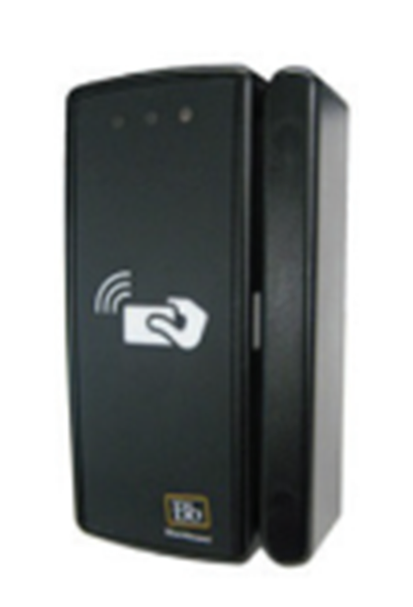
To access this space, customers will need either:
an updated physical Purdue ID card (printed after August 2022)
or Mobile Credentials compatible with this technology.

REMINDER
Students: Mobile First
Faculty and Staff: Mobile Option

For more information, please visit
Purdue ID Card Operations/Support website
