
BME Distinguished Seminar

Wednesday, April 8, 2026
9:30 – 10:30 am, MJIS 1001
Students registered for the seminar are expected to attend in person.
Teams Meeting ID: 211 123 896 292 8 Passcode: Uh9qs2pf

“Decoding and Targeting Epileptic Brain States”
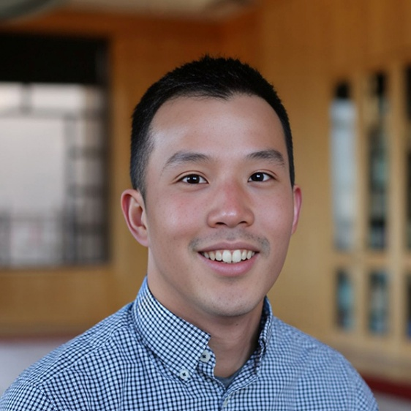

Ritchie Chen, PhD
Assistant Professor, Neurological Surgery
Kinetics Foundation Chair in Translational Research
University of California, San Francisco

Abstract:
Temporal lobe epilepsy (TLE) is among the most common neurological disorders, yet about 30% of patients do not respond to existing medications and continue to experience seizures. To advance new therapies, I will present our recent work developing engineered phenotyping platforms for biomarker discovery in mouse models of TLE. Using a multimodal system that synchronizes neural and kinematic measurements, we identified latent, epilepsy-associated neural-behavioral states by decoding continuous EEG and behavioral syllables. I will then discuss emerging therapeutic modalities and molecular targets to achieve seizure remission and conclude with pathways towards clinical translation.

BIOGRAPHY:
Dr. Ritchie Chen is an Assistant Professor of Neurological Surgery and of Bioengineering and Therapeutic Sciences at the University of California, San Francisco. He received his BS from UC Berkeley and his PhD in Materials Science and Engineering from MIT. He then conducted postdoctoral research in Bioengineering at Stanford University. Dr. Chen's research group integrates bioengineering and systems neuroscience to develop neurotechnologies for mapping and controlling neural circuits with cell-type specificity. These tools are used to investigate brain function and guide new therapeutic strategies for neurological disorders.

