BME 69500 Pediatric Medical Devices (CRN 14011)
Fall 2025, 3.0 credit hours
Wednesdays 10:30am-1:20pm in MJIS 1083 (in person attendance only)
Prerequisite: Biomedical Engineering Graduate Standing

Course Description: The unique medical needs of pediatric patients in the context of current and emerging clinical technologies are presented in this novel course. Anatomical, physiological, and pathophysiological underpinnings of diseases in infants and children are studied. Unique aspects of pediatric device design, regulation, and translation, including clinical studies and ethical considerations, are explored. Numerous clinical subspecialties such as neonatology, cardiology, surgery, nephrology, pulmonology, orthopedics, and gastroenterology are examined in terms of available technologies and remaining clinical needs. Future directions in device development and emerging trends in patient care are considered throughout.
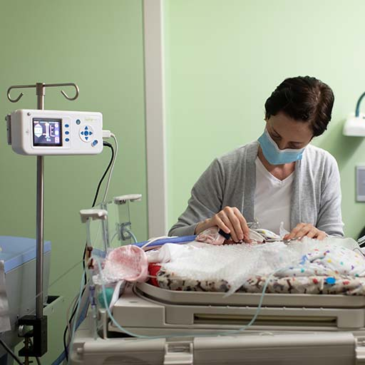

Weekly Course Topics:
August 27 Pediatrics Introduction
September 3 Neonatology Introduction
September 10 Pediatric Device Design
September 17 Pediatric Device Regulation
September 24 Pediatric Device Case Studies
October 1 Pediatric Clinical Studies
October 15 Pediatric Cardiology
October 22 Pediatric Cardiovascular Surgery
October 29 Pediatric Pulmonology
November 5 Pediatric Nephrology
November 12 Pediatric Orthopedic Surgery
November 19 Pediatric Gastroenterology
December 3 Ethical Considerations in Pediatrics
December 10 Student Presentations

Primary Instructor: George Wodicka, MJIS 3036, wodicka@purdue.edu
Numerous experts from the Indiana University School of Medicine Department of Pediatrics, Riley Hospital for Children, Cook Medical, Inc., and OrthoPediatrics, Inc. will actively participate.

