
Distinguished Seminar Series

Wednesday, January 22, 2025
9:30 – 10:20am, MJIS 1001
https://purdue-edu.zoom.us/j/95998206988

“Extracellular vesicle therapeutics: Bioengineering solutions across cellular domains”

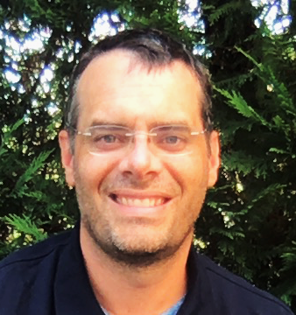

Steven M. Jay, Ph.D

Associate Professor
Fischell Department of Bioengineering
University of Maryland

Abstract: My research group aims to uncover new biological insights towards the design, production, and delivery of biotherapeutics. We are particularly interested in cell-derived products from both humans and bacteria, especially human extracellular vesicles (EVs, including exosomes) and bacterial extracellular vesicles (BEVs, including outer membrane vesicles (OMVs)). In this talk, I will discuss how we have been addressing limitations related to the potency and scalable biomanufacturing of EVs and BEVs. Specifically, we have conducted fundamental mechanobiological studies of EV production and have utilized the knowledge gained to rationally design 3D-printed bioreactor systems for large-scale EV production with enhanced therapeutic potential for wound repair. We have also employed a genetic engineering strategy to create hypervesiculating BEV producer cells capable of generating mass quantities of therapeutic BEVs that we have applied and validated in animal models of inflammatory bowel disease.

Bio: Dr. Steven Jay leads a research group in the Fischell Dept. of Bioengineering at the University of Maryland that investigates the therapeutic potential of biopharmaceuticals, with a specific focus on extracellular vesicles from both human and bacterial sources. He initially trained as an undergraduate in biological engineering at the University of Georgia. He then completed his PhD at Yale University, working with Dr. Mark Saltzman, studying biopolymer drug delivery, followed by postdoctoral training with Drs. Richard Lee (Brigham and Women’s Hospital) and Linda Griffith (MIT) focused on protein design and engineering.

~BME Host: Leopold Green~

