

Wednesday, March 29, 2023
2:00 – 3:00 pm, MJIS 2001 or via zoom

https://purdue-edu.zoom.us/j/93919059918?pwd=UURtUlMxc1J0UzFXWk1YMFdzaVRyZz09&from=addon
“A Brief History of Cerebral Aneurysms”

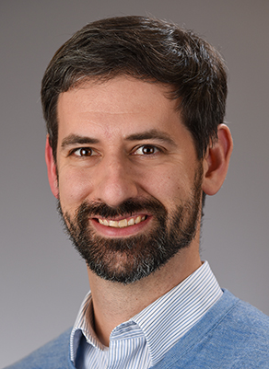

Bradley Bohnstedt, Ph.D.
Associate Professor
Director of Neurovascular Disease
Neurosurgery Clerkship Director
Indiana University School of Medicine

Biography: Associate professor of Neurosurgery at IUSOM, Chief of division of Neurovascular, Fellowship director for Neuroendovascular and Cerebrovascular Surgery. Prior to coming back to IU was in Oklahoma for 5.5 years in Neurosurgery as the Director of Cerebrovascular and Endovascular Neurosurgery. Assistant professor in Neurosurgery at OUHSC. Fellowship Neuroendovascular Surgery and Cerebrovascular surgery, Indianapolis Residency IUSOM Department of Neurosurgery, Indianapolis Medical School, IUSOM. Native Hoosier.

~ BME Host: Hugh Lee ~

