

Wednesday, March 29, 2023
2:00 – 3:00 pm, MJIS 2001 or via zoom
https://purdue-edu.zoom.us/j/93919059918?pwd=UURtUlMxc1J0UzFXWk1YMFdzaVRyZz09&from=addon

“Towards Personalized Endovascular Treatment of Unruptured Intracranial Aneurysms”

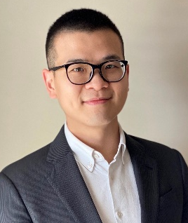

Chung-Hao Lee, Ph.D.
Associate Professor
School of Aerospace and Mechanical Engineering
Gallogly College of Engineering
The University of Oklahoma

Abstract: An intracranial aneurysm (ICA) is the focal dilatation of a brain artery, affecting about 1.3 million Americans. The ICAs, left untreated, can progressively grow, weaken the vessel wall, and eventually rupture—an unpredictable incident that causes hemorrhagic strokes, accounting for 5% of all new strokes each year. Endovascular coil embolization is the current gold standard for treating saccular ICAs. However, aneurysm recurrence can reach 44% within 5-6 years after the initial coil therapy, among which ~58% requires retreatment. Additional emerging challenges for coil embolization include recanalization and suboptimal post-implant occlusion, especially for treating ICAs with a complex 3D geometry. In the second part of this seminar, I will present our recent development of personalized embolic devices for treating unruptured saccular ICAs, that we use additive manufacturing for fabricating customizable shape memory polymer porous structure and a combined experimental/computational approach for iterative bioengineering design. Built upon the fundamental information on aneurysm characteristics derived from holistic biomechanical and hemodynamic analyses, this project will potentially lead to a cutting-edge solution for ICA embolization, allowing individual-optimized aneurysm filling and, therefore, long-lasting occlusion performance.

Biography: Dr. Chung-Hao Lee is an associate professor of Aerospace and Mechanical Engineering at the University of Oklahoma (OU) with his biomechanics research program addressing several clinically important cardiovascular and cerebrovascular diseases. Dr. Lee graduated with B.S. and M.S. degrees in Civil Engineering from National Taiwan University (2003 & 2005), and he received a Ph.D. in Civil Engineering (major in computational biomolecular mechanics) from UCLA in 2011.
Before he joined OU, Dr. Lee was an American Heart Association postdoctoral fellow at the University of Texas at Austin. Since 2016, Dr. Lee published 58 journal papers and 5 book chapters, with his research supported by the American Heart Association Scientist Development Grant, National Institutes of Health R01 Grant (2022-2027), among others. Dr. Lee is the recipient of OU’s University Distinguished Teaching Award (2020) and Vice President for Research and Partnership Research & Creative Activity Award (2022).

~ BME Host: Hugh Lee ~

