

Monday, October 4, 2021
Virtual Seminar

12:00 pm – 1:00 pm

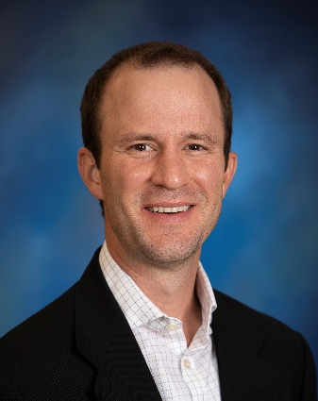

Craig Goergen, PhD
Leslie A. Geddes Associate Professor
Weldon School of Biomedical Engineering
Purdue University

Presenting

“Cardiovascular 4D Ultrasound and Photoacoustic Murine Imaging"

Join from computer or mobile:
https://iu.zoom.us/j/82470078226?pwd=Q0dPSnZKZGFvS0MyNDlueHNCQjhndz09
Meeting ID: 824 7007 8226
Password: 506986

Diabetes, Endocrine and Metabolic Research Series
Self-Claim Text Attendance
Please text 65603 to 317-671-8998
You have 60 minutes prior, during, and 120 minutes after the end of the activity
to text in your attendance

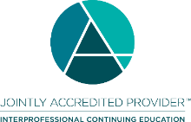
Accreditation Statement
In support of improving patient care, Indiana University School of Medicine is jointly accredited by the Accreditation Council for Continuing Medical Education (ACCME), the Accreditation Council for Pharmacy Education (ACPE), and the American Nurses Credentialing Center (ANCC), to provide continuing education for the healthcare team.
Physicians
Indiana University School of Medicine designates this live activity for a maximum of 1.0 AMA PRA Category 1 Credits™. Physicians should claim only the credit commensurate with the extent of their participation in the activity.
Disclosure Summary
Indiana University School of Medicine (IUSM) policy ensures that those who have influenced the content of a CE activity (e.g. planners, faculty, authors, reviewers and others) disclose all financial relationships with any ineligible companies so that IUSM may identify and resolve any conflicts of interest prior to the activity. All educational programs sponsored by Indiana University School of Medicine must demonstrate balance, independence, objectivity, and scientific rigor.
There are no relevant financial relationship(s) with ineligible companies for anyone who was in control of the content of this activity.
*An ineligible company is any entity whose primary business is producing, marketing, selling, re-selling, or distributing healthcare products used by or on patients. Accreditation Expiration: 6/30/2022

Upcoming seminars:
Oct. 18 JD Damrath
Oct. 25 Kei Sakamoto
Nov. 1 Gulminay Mohsin & Rita Saroufim
Nov 8 Lale Ozcan
Nov 15 Ruth Gimeno
Nov 22 Bo Wang
Nov 29 Ana Maria Arbelaez

