Industrial & Physical Pharmacy

PhD Recruiting Event
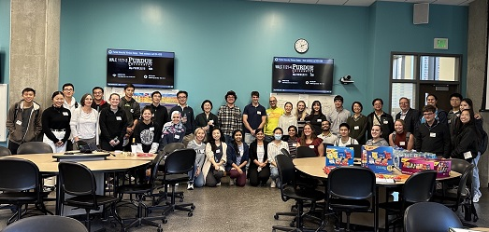

You are invited to visit with our professors and their graduate students. They will be on hand to talk about their research in the following Pharmaceutical Solids areas
- Formulation
- Manufacturing
- Delivery & Biopharmaceutics

When: Thursday, October 5, 2023
Where: WALC 1121
Time: 6:00 - 7:00pm

We will have pizza, chips, candy, and water

Link to apply: www.gradschool.purdue.edu
Deadline: December 1, 2023 for Fall 2024



