
Wednesday, April 15th, 2026
9:30 – 10:20am, MJIS 1001
Students registered for the seminar are expected to attend in-person.
Zoom link: https://purdue-edu.zoom.us/j/94493857130?pwd=rlCxqppEgIhrPcQk0LzUBZYEsa0aQG.1

“Uncovering the Neural Contribution to Biomaterial-Mediated Musculoskeletal Healing”

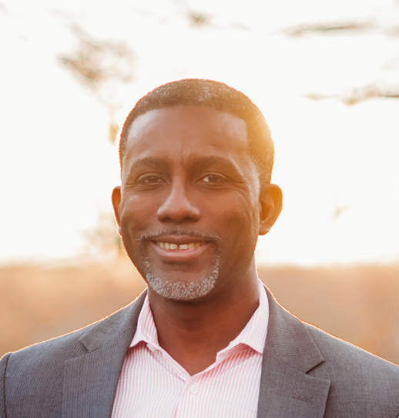
Warren Grayson, Ph.D.
Morton F. Goldberg Professor, and Director of the Translational Tissue Engineering Center
Department of Biomedical Engineering
Johns Hopkins University

Abstract: Tissue engineering provides a viable means of regenerating bone and skeletal muscle following injuries. Our lab has developed advanced biomaterial-based approaches to promote recovery following volumetric bone and muscle loss. To further improve biomaterial design, we focused on developing a robust understanding of heterotypic cellular interactions that are critical for healing. Specifically, both bone and skeletal muscle are highly vascularized and innervated tissues. Consequently, angiogenesis and neural infiltration are critical processes underlying their functional regeneration. Through our quantitative lightsheet microscopy platform, which can image the entire tissues at single-cell resolution, we are mapping the neurovascular associations during homeostasis, aging, and biomaterial-mediated healing to determine remaining gaps. Combined with transcriptomic approaches, this data is employed to identify novel therapeutic targets for bone and skeletal muscle.

Biography: Dr. Warren Grayson is the Morton F. Goldberg Professor and Vice-Chair of Faculty Affairs in the Department of Biomedical Engineering at Johns Hopkins University. His Laboratory for Craniofacial and Orthopaedic Tissue Engineering focuses on developing advanced therapeutics for the regeneration of bone and skeletal muscle. Dr. Grayson’s scientific contributions and impact have been recognized by various entities. He received awards from the Orthopaedic Research Society (2007), the American Society for Bone and Mineral Research (2013), Young Investigator Award from TERMIS (2014), and the prestigious Early Faculty CAREER Award from the National Science Foundation (2014).

~ BME Host: Taimoor H. Qazi ~

