
BME Distinguished Seminar

Wednesday, March 11, 2026
9:30 – 10:30 am, MJIS 1001
Students registered for the seminar are expected to attend in person.
Teams Meeting ID: 211 123 896 292 8 Passcode: Uh9qs2pf

“Advancing Nanomedicine with Molecular Imaging”
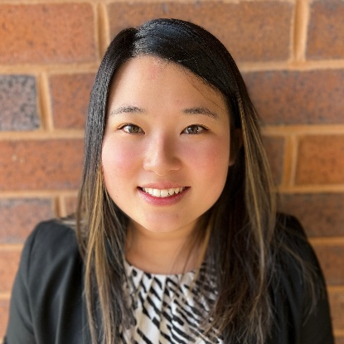

Jessica Hsu, PhD
Assistant Professor of Health Science
Purdue University

Abstract: Molecular imaging, which empowers the detection of physiological and pathological processes within living subjects, has a vital role in both preclinical and clinical diagnostics. Many newly emerging imaging agents are based on nanomaterials as their high payloads, unique physicochemical properties, improved sensitivity, multimodality capacity, and therapeutic functionality are highly desired for many advanced forms of bioimaging techniques and disease therapies. In this seminar, I will discuss the development of a multimodal contrast agent that can improve the detection of lesions in dense breasts and the considerations for designing translatable nanomaterial platforms. I will also highlight advances in tunable polymeric technologies that enhance the performance of cancer nanotheranostics. Additionally, I will present the latest work on bioactive nanoparticles for the imaging and treatment of acute kidney injury. Therefore, these findings provide insights into improving disease detection and therapy through the integration of nanomedicine and molecular imaging.

Biography: Dr. Jessica Hsu is an Assistant Professor in the School of Health Sciences at Purdue University. She received her BS in Nuclear Engineering from the University of Illinois at Urbana-Champaign and her PhD in Bioengineering from the University of Pennsylvania. She completed her postdoctoral training at the University of Wisconsin-Madison. She has authored >60 peer-reviewed publications and received numerous honors, including the NSF Graduate Research Fellowship, Philadelphia Foundation Brody Postdoctoral Fellowship, and MRS Best Oral Presentation Award. She is also a strong advocate for women in science and is deeply committed to creating a diverse, collaborative, and dynamic lab that prioritizes teaching and mentoring to empower all members to achieve excellence in research.

