

BME Summer Seminar Series
Wednesday, July 19th, 2023
9:30-10:30 AM EST
Via Zoom Meeting – link below*

Evaluation links:
Cameron Villarreal: https://purdue.ca1.qualtrics.com/jfe/form/SV_0eUiKgdroT1urJQ
Jae Young Park: https://purdue.ca1.qualtrics.com/jfe/form/SV_9p2aSOZR6u81LbE

The gut microbiome modulates the structure-function relationship in musculoskeletal tissue: More than a gut feeling
Cameron Villarreal (Deva Chan, advisor)

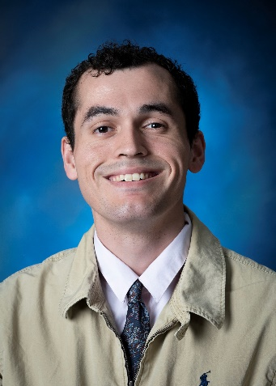

Abstract: The gut microbiome is a diverse and dynamic ecosystem that modulates numerous physiological processes across organ systems. Microbes and microbe metabolites have been shown to alter systemic inflammation, intestinal permeability, and nutrient metabolism. Each of these processes can be associated with musculoskeletal development and the underlying structure-function relationship in the various connective tissues of the musculoskeletal system. Beyond these indirect relationships, other work has shown that modulation of the gut microbiome in rodents by introducing a high-fat diet or antibiotics leads to an altered propensity for musculoskeletal diseases like osteoarthritis and altered bone material properties. While a wealth of evidence suggests that the gut microbiome has a widespread systemic effect in the musculoskeletal system, how it modulates the connective tissue in joints and underlying subchondral bone remains poorly understood hindering our ability to diagnose, treat, and prevent musculoskeletal disease. Through our work, we aim to examine how deviations from a steady state gut microbiome, or dysbiosis, may result in deleterious changes to bone quality, cartilage content, and markers of systemic inflammation. We examine alterations to the structure-function relationship in musculoskeletal tissue through a combination of imaging, biomechanics, and content assays. Additionally, we profile the gut microbiome through 16s with the goal of correlating changes in the gut microbiome to altered gut composition. This work seeks to enhance our understanding of the interrelatedness between the gut and the musculoskeletal system to enable improved treatment, both adjuvant and preventative, of musculoskeletal disease and injury.

Novel stretchable thin-film electronic device-based neuromodulation platforms for less-risky, easy, and reliable implantation
Jae Young Park (Hyowon Lee, advisor)

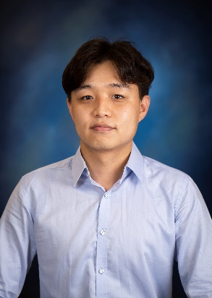

Abstract: Neuromodulation is increasingly utilized to rehabilitate a variety of biological functions, such as vision, hearing, movement, touch perception, and sense of self-movement, particularly in patients with severe or chronic diseases for whom other treatment options, including medication, have proven ineffective. Nevertheless, due to concerns about the cost and safety of surgical processes, many are hesitant to proceed with this option. Concerns particularly arise from the potential displacement of the electrode caused by movements at the target site due to air infiltration or cerebrospinal fluid loss during surgery. Other issues including technical errors, failure in lead fixation, Twiddler syndrome, and Pneumocephalus can also result in electrode dislocation. This misalignment can lead to off-target effect that can have severe repercussions for patients. In address these issues, we have developed two novel platforms and accompanying surgical strategies to enable safer, more accurate, and easier implantation: 1. Flexible electronic catheter for Deep Brain Stimulation (DBS) 2. Adhesive-hydrogel-integrated cuff electrodes for Vagus Nerve Stimulation (VNS). To achieve these multifaceted objectives, we designed a stretchable thin-film electronic device using polyimide-based microfabrication techniques, which is compliant to other functional medical platforms. By integrating this device with silicone catheter and adhesive hydrogel, we have endowed the device with new functionality that facilitate novel implantation methodologies.

*Join Zoom Meeting
https://purdue-edu.zoom.us/j/98231659969?pwd=T21Oa1B6QzFyQzFvckMzS1doNGlJUT09

Meeting ID: 982 3165 9969
Passcode: biomedical

